BJS10111
Therapeutic antibiotics for simple hand injuries requiring surgery

G. R. F. Murphy, M. D. Gardiner, G. E. Glass, I. A. Kreis, A. Jain and S. Hettiaratchy

Table 1 Characteristics of included studies

Altergott et al.¹⁴ (2008)
Methods | Prospective randomized unblinded trial
Participants | 146 children undergoing surgical treatment of fingertip injuries  Setting: Los Angeles, USA  September 2000 to July 2004
Interventions | Two arms  Treatment group received cephalexin 50 mg/kg in 3 divided doses daily for 7 days  Comparison group received no antibiotic after surgery
Outcomes | Infection rate at 7 days
Risk of bias
Bias | Authors’ judgement | Support for judgement
Random sequence generation (selection bias) | Low risk | Computerized randomization list
Allocation concealment  (selection bias) | High risk | Not blinded
Blinding of participants and personnel  (performance bias) | High risk | Not blinded
Blinding of outcome assessment (detection bias) | High risk | Not blinded
Incomplete outcome data  (attrition bias) | Low risk | 7.5% drop-out rate, equal numbers in both groups, similar reasons for drop-out between groups
Selective reporting  (reporting bias) | Low risk | All expected outcomes reported
Other bias

Aydin et al.¹⁵ (2010)
Methods | Prospective randomized double-blind clinical trial
Participants | 384 patients undergoing hand surgery for trauma  Setting: Ankara, Turkey  2003–2008
Interventions | Two arms  Treatment group received cefazolin 2 g i.v. 4-hourly for 24 h from surgery  Comparison group received placebo to the same regimen
Outcomes | Infection rate at 12 days
Notes | This is a subgroup of a larger study covering all hand surgery
Risk of bias
Bias | Authors’ judgement | Support for judgement
Random sequence generation (selection bias) | High risk | Allocation by odd versus even study number
Allocation concealment  (selection bias) | High risk | Allocation by alternation
Blinding of participants and personnel  (performance bias) | Low risk | Blinded adequately
Blinding of outcome assessment (detection bias) | Low risk | Blinded adequately
Incomplete outcome data  (attrition bias) | Low risk | 1.8% drop-out rate, equal numbers in both groups, similar reasons for drop-out between groups
Selective reporting  (reporting bias) | Unclear risk | Insufficient information to judge
Other bias

Beesley et al.¹⁶ (1975)
Methods | Prospective randomized double-blind clinical trial
Participants | 145 patients over 5 years old with minor hand lacerations  Setting: Hereford, UK  ?1970s (trial dates not reported)
Interventions | Two arms  Treatment group received Magnapen®(ampicillin/flucloxacillin; Wockhardt UK, Wrexham, UK) 500 mg q.d.s. for 5 days after surgery  Comparison group received placebo to the same dosing schedule
Outcomes | Infection rate at 5 days
Risk of bias
Bias | Authors’ judgement | Support for judgement
Random sequence generation (selection bias) | High risk | Allocation by registration number
Allocation concealment  (selection bias) | High risk | Allocation by alternation
Blinding of participants and personnel  (performance bias) | Low risk | Blinded adequately
Blinding of outcome assessment (detection bias) | Unclear risk | Insufficient information to judge
Incomplete outcome data  (attrition bias) | Low risk | 10% drop-out rate, similar numbers and reasons for drop-out between groups
Selective reporting  (reporting bias) | Unclear risk | Insufficient information to judge
Other bias

Berwald et al.¹⁷ (2014)
Methods | Prospective randomized double-blind clinical pilot trial
Participants | 78 adult patients with simple hand lacerations requiring repair  Setting: New York, USA (2 academic hospital emergency departments)  February 2010 to February 2012
Interventions | Three arms  Group 1 received cephalexin 500 mg p.o. t.d.s.for 7 days  Group 2 received clindamycin 300 mg p.o. t.d.s. for 7 days  Group 3 received placebo p.o. t.d.s. for 7 days
Outcomes | Feasibility (patient flow through study)  Infection rate at 10–14 days  Patient satisfaction on a visual analogue scale
Risk of bias
Bias | Authors’ judgement | Support for judgement
Random sequence generation (selection bias) | Low risk | Computerized block randomization
Allocation concealment  (selection bias) | Low risk | Allocation stored in sealed opaque envelopes in pharmacy
Blinding of participants and personnel  (performance bias) | Low risk | Allocation stored in sealed opaque envelopes in pharmacy
Blinding of outcome assessment (detection bias) | Low risk | Code not broken until after outcome assessment
Incomplete outcome data  (attrition bias) | Low risk | 6% drop-out rate, even distribution
Selective reporting  (reporting bias) | Low risk | All expected outcomes reported
Other bias

Cassell and Ion¹⁸ (1997)
Methods | Prospective systematic allocation
Participants | 250 consecutive patients undergoing surgical treatment of upper limb lacerations  Setting: Swansea, UK  1990s (not specified)
Interventions | Two arms  Treatment group received co-amoxiclav i.v. at surgery, plus p.o. t.d.s. for 5 days  Comparison group received no antibiotic before or after surgery
Outcomes | Wound infection rate at suture removal (mean 14 days)
Risk of bias
Bias | Authors’ judgement | Support for judgement
Random sequence generation (selection bias) | High risk | Allocation by odd versus even hospital number
Allocation concealment  (selection bias) | High risk | Allocation by odd versus even hospital number
Blinding of participants and personnel  (performance bias) | High risk | Not blinded
Blinding of outcome assessment (detection bias) | High risk | Not blinded
Incomplete outcome data  (attrition bias) | Low risk | 9.6% drop-out rate, similar numbers and reasons for drop-out between groups
Selective reporting  (reporting bias) | Unclear risk | Insufficient information to judge
Other bias

Grossman et al.¹⁹ (1981)
Methods | Prospective randomized unblinded trial
Participants | 280 patients undergoing surgical treatment of hand lacerations  Setting: Washington, USA  Circa 1980 (not specified)
Interventions | Three arms  Group 1 received cephalexin 250 mg p.o. q.d.s. for 6 days  Group 2 received cefazolin 1 g i.m. immediately after surgery  Group 3 received placebo i.m. immediately after surgery
Outcomes | Infection rate until suture removal (time frame not specified)
Risk of bias
Bias | Authors’ judgement | Support for judgement
Random sequence generation (selection bias) | High risk | Open allocation by selection of prefilled protocol sheet
Allocation concealment  (selection bias) | High risk | Not blinded from surgeon
Blinding of participants and personnel  (performance bias) | High risk | Not blinded from surgeon
Blinding of outcome assessment (detection bias) | Unclear risk | Insufficient data reported to form a judgement
Incomplete outcome data  (attrition bias) | Low risk | 5.4% drop-out rate, similar numbers and reasons for drop-out between groups
Selective reporting  (reporting bias) | Unclear risk | Insufficient data reported to form a judgement
Other bias

Haughey et al.²⁰ (1981)
Methods | Prospective randomized unblinded trial
Participants | 394 patients undergoing surgical treatment of hand wounds  Setting: Pennsylvania, USA  September 1978 to June 1979
Interventions | Two arms  Treatment group received cephalexin 250 mg p.o. q.d.s. for 4 days (6.25 mg per kg per 24 h in children).  Comparison group received no antibiotic after surgery
Outcomes | Infection rate when wound healed (time frame unspecified)
Notes | Per-protocol analysis, with significant cross-over
Risk of bias
Bias | Authors’ judgement | Support for judgement
Random sequence generation (selection bias) | High risk | Allocation by hospital number
Allocation concealment  (selection bias) | High risk | Not blinded
Blinding of participants and personnel  (performance bias) | High risk | Not blinded
Blinding of outcome assessment (detection bias) | Unclear risk | Insufficient data reported to form a judgement
Incomplete outcome data  (attrition bias) | High risk | ‘As treated’ analysis done, with substantial cross-over between groups
Selective reporting  (reporting bias) | Unclear risk | Insufficient data reported to form a judgement
Other bias

Platt and Page²¹ (1995)
Methods | Prospective cohort study
Participants | 124 patients undergoing surgical treatment of hand wounds  Setting: Sheffield, UK  August to November 1993
Interventions | No intervention  Observational comparison of antibiotic (flucloxacillin, or cefuroxime, or erythromycin +/– metronidazole) versus no antibiotic
Outcomes | Infection rate at suture removal (approximately 2 weeks)
Risk of bias
Bias | Authors’ judgement | Support for judgement
Random sequence generation (selection bias) | n.a. | No intervention
Allocation concealment  (selection bias) | n.a. | No intervention
Blinding of participants and personnel  (performance bias) | n.a. | No intervention
Blinding of outcome assessment (detection bias) | n.a. | No intervention
Incomplete outcome data  (attrition bias) | Unclear risk | Insufficient data reported to form a judgement
Selective reporting  (reporting bias) | Unclear risk | Insufficient data reported to form a judgement
Other bias

Roberts and Teddy²² (1977)
Methods | Prospective randomized unblinded trial
Participants | 368 patients undergoing surgical treatment of hand wounds  Setting: Oxford, UK  A 6-month period, ?circa 1975 (not specified)
Interventions | Three arms  Group 1 received Triplopen (GlaxoSmithKline, Brentford, UK) one vial i.m. immediately after surgery (½ vial if aged 2–10 years, ¼ vial if < 2 years  Group 2 received flucloxacillin 250 mg p.o. q.d.s. for 7 days after surgery (half dose if < 5 years)  Group 3 received no treatment
Outcomes | Infection rate at 7 days
Risk of bias
Bias | Authors’ judgement | Support for judgement
Random sequence generation (selection bias) | Unclear risk | Insufficient data reported to form a judgement
Allocation concealment  (selection bias) | High risk | Not blinded
Blinding of participants and personnel  (performance bias) | High risk | Not blinded
Blinding of outcome assessment (detection bias) | Unclear risk | Insufficient data reported to form a judgement
Incomplete outcome data  (attrition bias) | Low risk | 9% drop-out rate, similar numbers and reasons for drop-out between groups
Selective reporting  (reporting bias) | Unclear risk | Insufficient data reported to form a judgement
Other bias

Roodsari et al.²³ (2015)
Methods | Prospective cohort study
Participants | 125 patients undergoing surgical treatment of hand injuries  Setting: New York, USA  September 2010 to July 2011
Interventions | No intervention – observational cohort study.  Comparison of antibiotic treatment versus no antibiotics
Outcomes | Infection rate at 10–14 days  Visual analogue score for appearance at 30 days
Risk of bias
Bias | Authors’ judgement | Support for judgement
Random sequence generation (selection bias) | n.a. | Observational study
Allocation concealment  (selection bias) | n.a. | Observational study
Blinding of participants and personnel  (performance bias) | n.a. | Observational study
Blinding of outcome assessment (detection bias) | n.a. | Observational study
Incomplete outcome data  (attrition bias) | Unclear risk | Insufficient data reported to form a judgement
Selective reporting  (reporting bias) | Low risk | All expected outcomes reported
Other bias

Stone and Davidson²⁴ (1998)
Methods | Retrospective cohort study
Participants | 140 patients undergoing surgical treatment for open flexor tendon injuries (zones I – IV)  Setting: Ontario, Canada  July 1988 to July 1993
Interventions | No intervention  Comparison of infection rate between antibiotic versus no antibiotic
Outcomes | Infection rate as noted in routine clinical follow-up
Risk of bias
Bias | Authors’ judgement | Support for judgement
Random sequence generation (selection bias) | n.a. | Observational study
Allocation concealment  (selection bias) | n.a. | Observational study
Blinding of participants and personnel  (performance bias) | n.a. | Observational study
Blinding of outcome assessment (detection bias) | n.a. | Observational study
Incomplete outcome data  (attrition bias) | Unclear risk | Insufficient data reported to form a judgement
Selective reporting  (reporting bias) | Unclear risk | Insufficient data reported to form a judgement
Other bias

Whittaker et al.²⁵ (2005)
Methods | Prospective randomized double-blind clinical trial
Participants | 170 patients undergoing surgical treatment of clean incised hand injuries  Setting: Stourbridge, UK  November 1996 to December 1998
Interventions | Three arms  Group 1 received flucloxacillin 1g i.v. immediately during surgery, then placebo p.o. q.d.s. for 5 days.  Group 2 received flucloxacillin 1 g i.v. immediately during surgery, then flucloxacillin 500 mg p.o. q.d.s. for 5 days  Group 3 received postoperative placebo p.o. q.d.s. for 5 days
Outcomes | Infection rate at 1, 2 and 4 weeks
Risk of bias
Bias | Authors’ judgement | Support for judgement
Random sequence generation (selection bias) | Unclear risk | Insufficient information to form a judgement
Allocation concealment  (selection bias) | Low risk | Sealed, opaque, sequential envelopes
Blinding of participants and personnel  (performance bias) | Low risk | Blinded to surgeon and patient
Blinding of outcome assessment (detection bias) | Low risk | Blinded to assessor
Incomplete outcome data  (attrition bias) | Low risk | 6.7% drop-out rate, similar numbers and reasons for drop-out between groups
Selective reporting  (reporting bias) | Unclear risk | Insufficient information to form a judgement
Other bias

Worlock et al.²⁶ (1980)
Methods | Prospective randomized double-blind clinical trial
Participants | 118 patients undergoing surgical treatment of hand injuries  Setting: London, UK  July 1977 to July 1978
Interventions | Three arms  Group 1 received placebo p.o. q.d.s. for 5 days  Group 2 received cephalexin 250 mg p.o. q.d.s. for 5 days  Group 3 received cephalexin 500 mg p.o. q.d.s. for 5 days
Outcomes | Infection rate at 5 and 14 days
Risk of bias
Bias | Authors’ judgement | Support for judgement
Random sequence generation (selection bias) | Unclear risk | Insufficient information to form a judgement
Allocation concealment  (selection bias) | Unclear risk | Insufficient information to form a judgement
Blinding of participants and personnel  (performance bias) | Unclear risk | Insufficient information to form a judgement
Blinding of outcome assessment (detection bias) | Unclear risk | Insufficient information to form a judgement.
Incomplete outcome data  (attrition bias) | Low risk | 11% drop-out rate, but similar numbers and reasons for drop-out between groups.
Selective reporting  (reporting bias) | Unclear risk | Insufficient information to form a judgement.
Other bias

i.v., Intravenous; q.d.s., four times daily; p.o. orally; t.d.s., three times daily; i.m., intramuscular; n.a., not applicable.

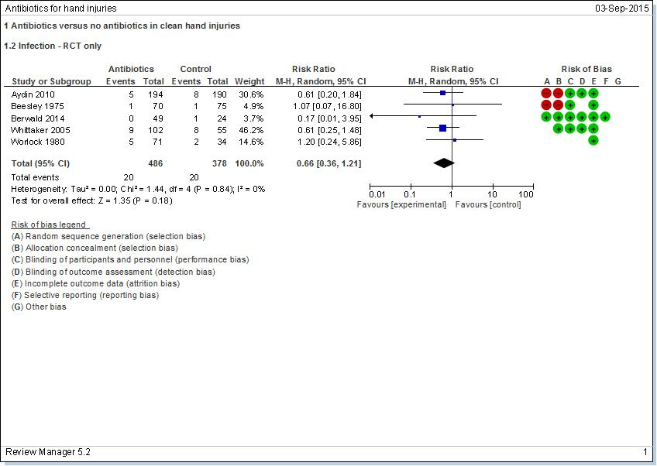

Fig. S1 Forest plot showing infection rate after surgery for simple hand injury in patients with versus without therapeutic antibiotics: randomized clinical trials only. A Mantel–Haenszel random-effects model was used for meta-analysis. The risk of bias in each study is also summarized: –, high risk of bias; +, low risk of bias

