Production of hollow and porous Fe₂O₃ from industrial mill scale and its potential for large-scale electrochemical energy storage applications
Chaopeng Fu, * Amoghavarsha Mahadevegowda, Patrick S. Grant
Department of Materials, University of Oxford, Oxford, United Kingdom, OX1 3PH
* E-mail: chaopeng.fu@materials.ox.ac.uk

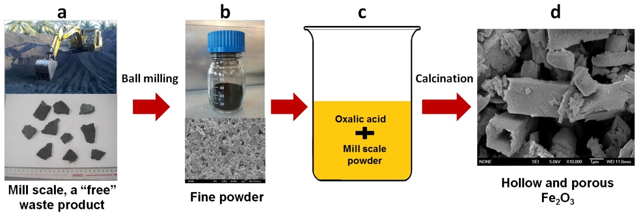
Figure 1: Schematic diagram of the simple preparation route to convert mill scale to hollow Fe₂O₃ micro-rods.
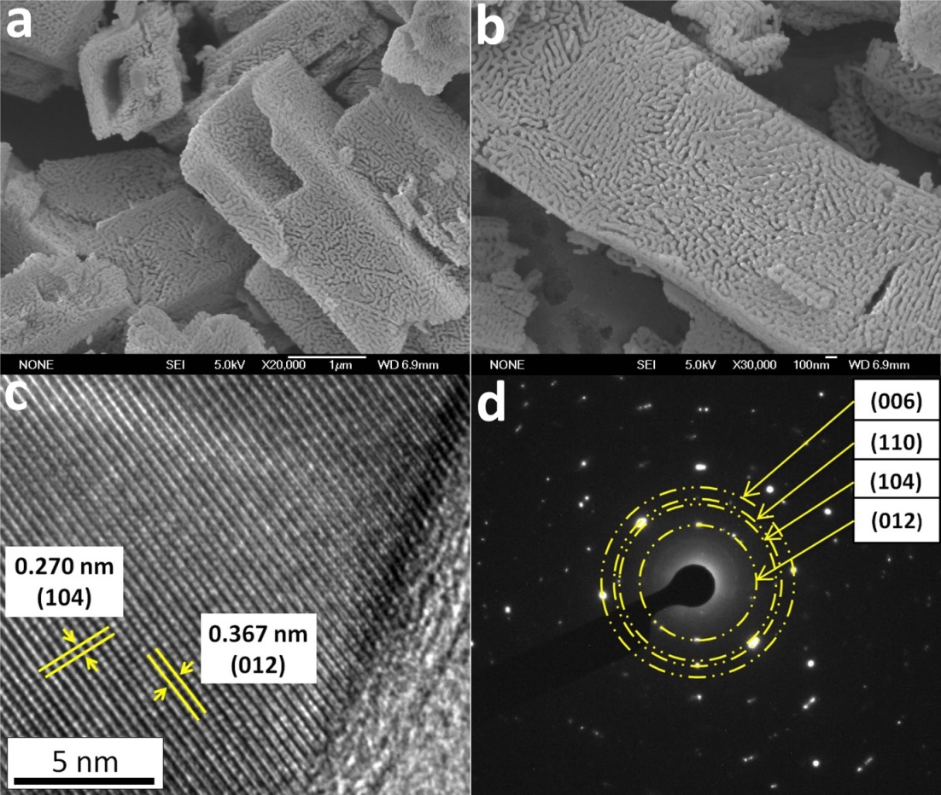
Figure 2: (a and b) SEM images, (c) HR-TEM image and (d) SAED pattern of the calcined powder derived from mill scale.

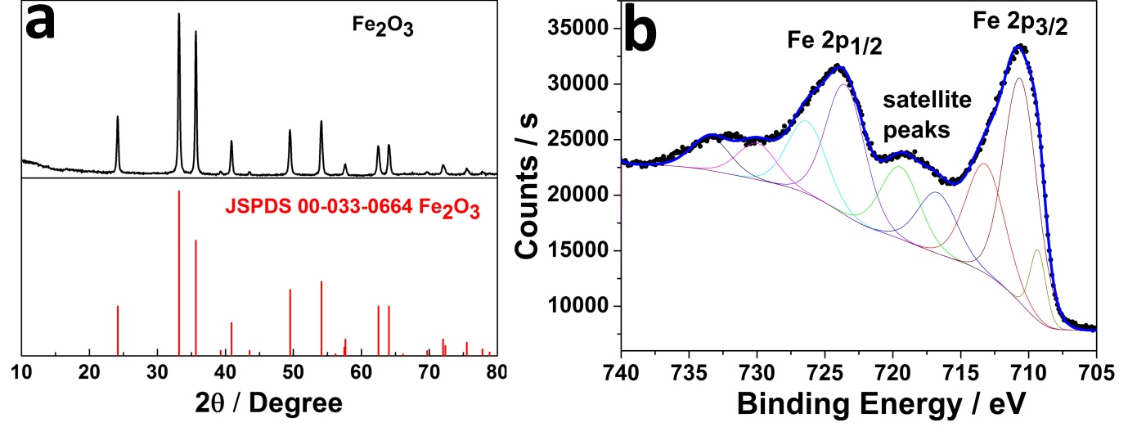
Figure 3: (a) XRD patterns and (b) Fe 2p XPS spectrum of the calcined powders.

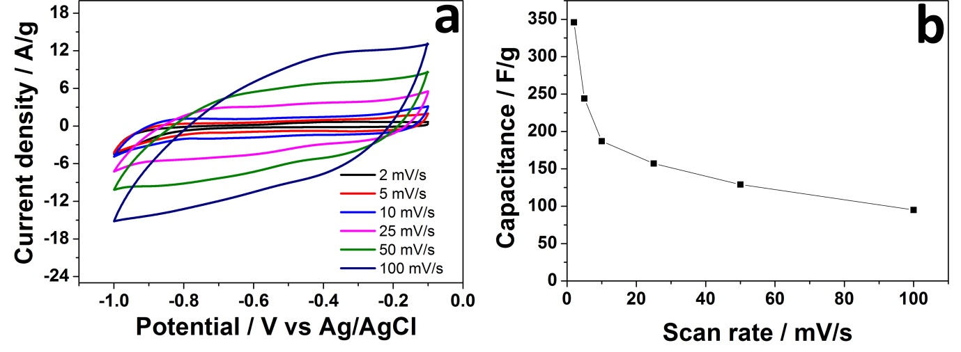
Figure 4: (a) CV curves of the hollow and porous Fe₂O₃- based electrode at a range of scan rates from 5 to 100 mV s⁻¹, and (b) specific capacitance as a function of scan rate.

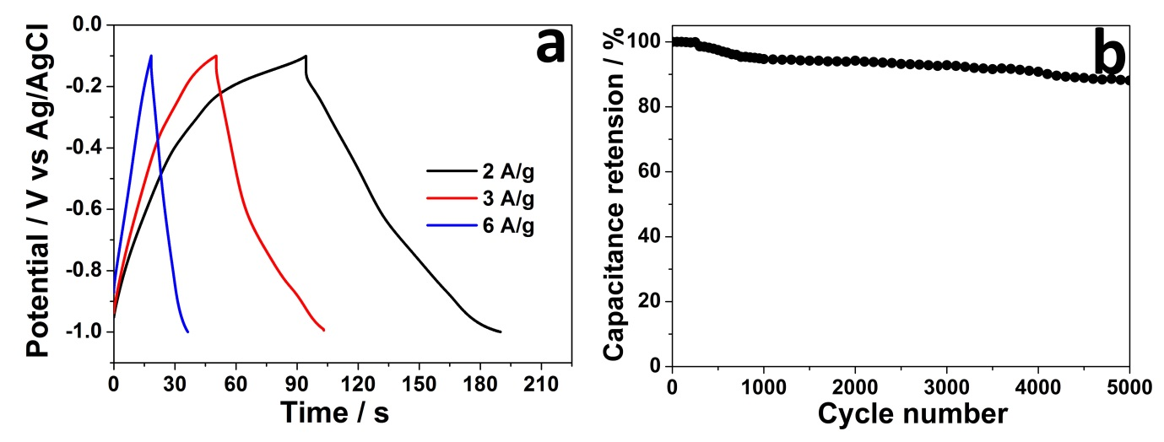Figure 5: (a) Charge/discharge curves of the hollow and porous Fe₂O₃-based electrodes at various current densities, and (b) specific capacitance from the discharge curves as a function of cycle number.

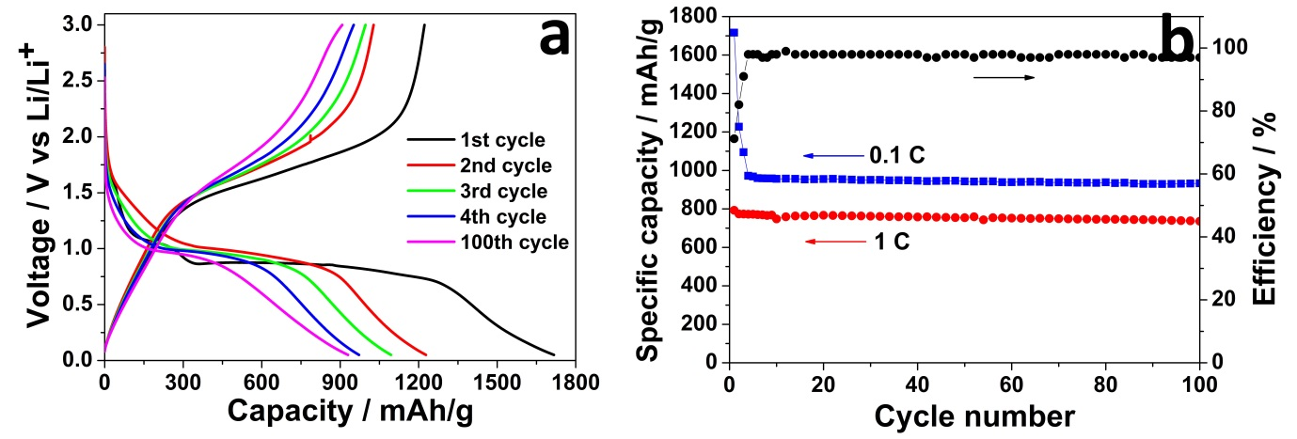Figure 6: (a) Charge/discharge curves of the hollow Fe₂O₃-based electrodes at 0.1 C, and (b) the specific capacity at 0.1 C and 1 C and Coulomobic efficiency at 0.1 C as a function of cycle number.

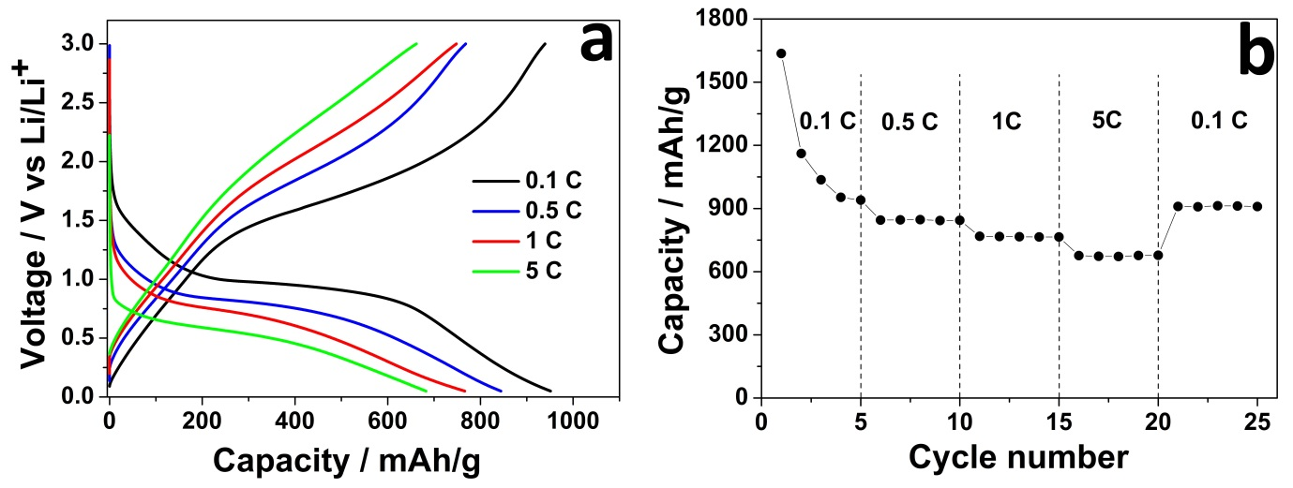
Figure 7: (a) charge/discharge curves of the hollow and porous Fe₂O₃-based electrode at various C rates, and (b) specific capacity at various C rates.

