SUPPLEMENTARY INFORMATION
The burden of long COVID: a multinational cohort analysis of Spanish and UK data including SARS-CoV-2 infections, reinfections, and matched contemporaneous test negative controls

Long COVID Algorithm
Figure S1: Algorithm to identify long COVID in routinely collected data
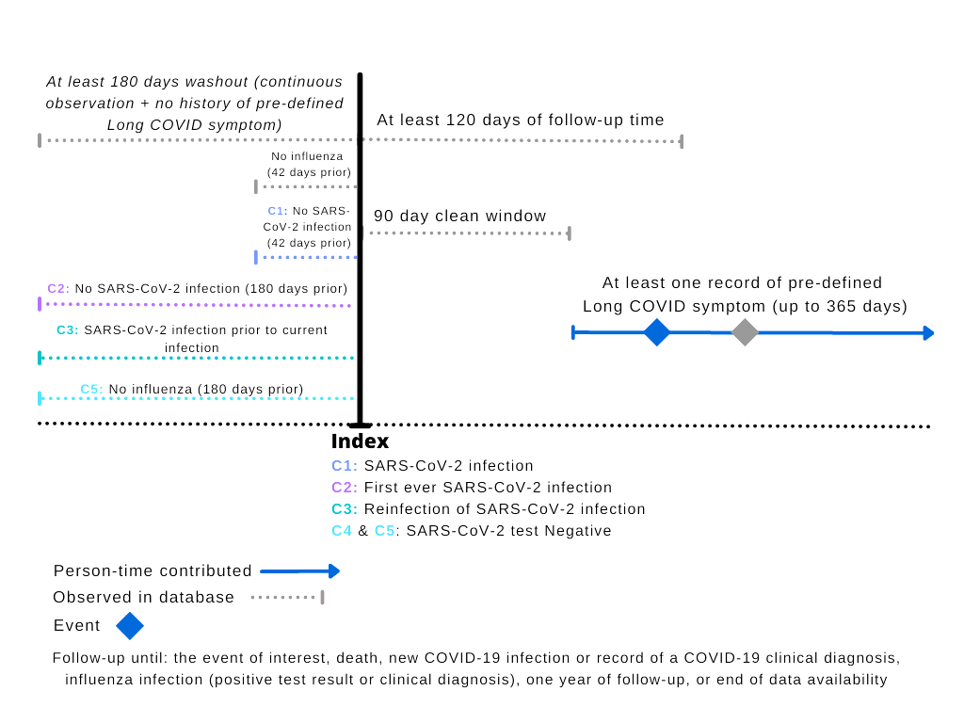

Baseline characteristics for additional cohorts

Table S1: Baseline characteristics of the first infections, re-infections, and all negative SARS-CoV-2 test records cohorts
 | SIDIAP |  |  | CPRD
 | First infections | Re-infections | All SARS-CoV-2 negative tests | First infections | Re-infections | All SARS-CoV-2 negative tests
N | 456,236 | 13,267 | 2,785,887 | 303,124 | 711 | 1,265,539
Days of follow-up (median [IQR]) | 360 [254, 365] | 306 [234, 365] | 348 [240, 365] | 151 [130, 188] | 142 [127, 173] | 173 [139, 205]
Age (median [IQR]) | 43 [30, 57] | 46 [30, 63] | 47 [34, 63] | 41 [29, 54] | 46 [31, 59] | 40 [29, 53]
Age, categories (%)
≤34 | 153,584 (33.7) | 4,194 (31.6) | 718,989 (25.8) | 112,506 (37.1) | 227 (31.9) | 476,931 (37.7)
35-49 | 135,679 (29.7) | 3,228 (24.3) | 779,095 (28.0) | 89,852 (29.6) | 171 (24.1) | 383,451 (30.3)
50-64 | 97,461 (21.4) | 2,703 (20.4) | 658,556 (23.6) | 73,550 (24.3) | 196 (27.6) | 286,474 (22.6)
65-79 | 46,848 (10.3) | 1,401 (10.6) | 439,079 (15.8) | 20,945 (6.9) | 69 (9.7) | 88,615 (7.0)
≥80 | 22,664 (5.0) | 1,741 (13.1) | 190,168 (6.8) | 6,271 (2.1) | 48 (6.8) | 30,068 (2.4)
Sex, female (%) | 239,168 (52.4) | 8,094 (61.0) | 1,540,225 (55.3) | 165,962 (54.8) | 471 (66.2) | 737,510 (58.3)
Test date period (%)
Sep-Dec 2020 | 143,737 (31.5) | 3,238 (24.4) | 907,680 (32.6) | 243,501 (80.3) | 523 (73.6) | 1,133,771 (89.6)
Jan-Apr 2021 | 133,732 (29.3) | 3,996 (30.1) | 877,404 (31.5) | 59,623 (19.7) | 188 (26.4) | 131,768 (10.4)
May-Aug 2021 | 153,882 (33.7) | 4,735 (35.7) | 666,648 (23.9)
Sep-Dec 2021 | 24,885 (5.5) | 1,298 (9.8) | 334,155 (12.0)
Vaccination status (%)
Not vaccinated | 366,696 (80.4) | 9,664 (72.8) | 2,027,450 (72.8) | 301,705 (99.5) | 689 (96.9) | 1,262,881 (99.8)
First dose | 38,258 (8.4) | 1,804 (13.6) | 200,421 (7.2) | 1,365 (0.5) | 20 (2.8) | 2,536 (0.2)
Two doses | 50,911 (11.2) | 1,768 (13.3) | 548,617 (19.7) | 54 (0.0) | <5 | 116 (0.0)
Three or more (booster) doses | 371 (0.1) | 31 (0.2) | 9,399 (0.3) | <5 | <5 | 6 (0.0)
COVID-19 PCR test (%) | 228,211 (50.0) | 8,803 (66.4) | 1,775,195 (63.7) | 283,428 (93.5) | 558 (78.5) | 1,155,843 (91.3)
Comorbidities (%)
Asthma | 34,622 (7.6) | 1,165 (8.8) | 233,164 (8.4) | 48,137 (15.9) | 142 (20.0) | 221,698 (17.5)
Autoimmune disease | 8,140 (1.8) | 373 (2.8) | 68,163 (2.4) | 6,113 (2.0) | 15 (2.1) | 27,780 (2.2)
COPD | 11,822 (2.6) | 670 (5.1) | 127,844 (4.6) | 3,850 (1.3) | 26 (3.7) | 20,410 (1.6)
Dementia | 6,578 (1.4) | 793 (6.0) | 42,429 (1.5) | 2,851 (0.9) | 28 (3.9) | 17,006 (1.3)
Diabetes | 38,483 (8.4) | 1,646 (12.4) | 286,329 (10.3) | 21,068 (7.0) | 93 (13.1) | 75,995 (6.0)
Heart disease | 49,658 (10.9) | 2,397 (18.1) | 416,455 (14.9) | 18,948 (6.3) | 90 (12.7) | 81,048 (6.4)
Cancer | 29,119 (6.4) | 1,353 (10.2) | 285,703 (10.3) | 11,937 (3.9) | 40 (5.6) | 53,765 (4.2)
Hypertension | 79,588 (17.4) | 3,278 (24.7) | 638,427 (22.9) | 39,057 (12.9) | 139 (19.5) | 153,793 (12.2)
Renal impairment | 18,799 (4.1) | 1,282 (9.7) | 168,173 (6.0) | 10,068 (3.3) | 58 (8.2) | 41,931 (3.3)
SIDIAP = Sistema d'Informació per al Desenvolupament de la Investigació en Atenció Primària, CPRD = Clinical Practice Research Datalink, IQR = interquartile range, with q25 and q75 provided. COPD = Chronic Obstructive Pulmonary Disease

Symptom distributions before matching

Table S2: Symptom distribution across cohorts (unmatched) - 90 days
 | SIDIAP |  |  |  |  |  | CPRD
 | COVID-19 infections | First infections | Re-infections | All SARS-CoV-2 negative tests | First SARS-CoV-2 negative tests |  |  | COVID-19 infections | First infections | Re-infections | All SARS-CoV-2 negative tests | First SARS-CoV-2 negative tests
N | 469,503 | 456,236 | 13,267 | 2,785,887 | 1,643,589 |  |  | 303,835 | 303,124 | 711 | 1,265,539 | 1,024,256
Long COVID symptoms, any (%) | 96,943 (20.6) | 93,440 (20.5) | 3,503  (26.4) | 591,067 (21.2) | 342,881 (20.9) |  |  | 23,782  (7.8) | 23,689  (7.8) | 93  (13.1) | 123,722 (9.8) | 99,175  (9.7)
Symptoms (%)
Abdominal pain | 16,024 (3.4) | 15,448 (3.4) | 576 (4.3) | 93,109 (3.3) | 53,842 (3.3) |  |  | 2,650 (0.9) | 2,642 (0.9) | 8 (1.1) | 14,312 (1.1) | 11,489 (1.1)
Allergy | 6,356 (1.4) | 6,121 (1.3) | 235 (1.8) | 36,513 (1.3) | 21,960 (1.3) |  |  | 933 (0.3) | 929 (0.3) | <5 | 4,519 (0.4) | 3,522 (0.3)
Altered smell or taste | 726 (0.2) | 710 (0.2) | 16 (0.1) | 991 (0.0) | 573 (0.0) |  |  | 201 (0.1) | 200 (0.1) | <5 | 174 (0.0) | 144 (0.0)
Anxiety | 9,500 (2.0) | 9,131 (2.0) | 369 (2.8) | 60,247 (2.2) | 34,153 (2.1) |  |  | 3,414 (1.1) | 3,407 (1.1) | 7 (1.0) | 20,645 (1.6) | 16,568 (1.6)
Blurred vision | 2,292 (0.5) | 2,201 (0.5) | 91 (0.7) | 13,905 (0.5) | 8,211 (0.5) |  |  | 115 (0.0) | 115 (0.0) | <5 | 615 (0.0) | 485 (0.0)
Chest pain | 5,884 (1.3) | 5,640 (1.2) | 244 (1.8) | 36,089 (1.3) | 20,474 (1.2) |  |  | 1,008 (0.3) | 1,004 (0.3) | <5 | 4,825 (0.4) | 3,940 (0.4)
Cognitive dysfunction | 1,094 (0.2) | 1,040 (0.2) | 54 (0.4) | 7,954 (0.3) | 4,508 (0.3) |  |  | 73 (0.0) | 72 (0.0) | <5 | 363 (0.0) | 269 (0.0)
Cough | 6,865 (1.5) | 6,579 (1.4) | 286 (2.2) | 41,643 (1.5) | 22,617 (1.4) |  |  | 1,682 (0.6) | 1,669 (0.6) | 13 (1.8) | 10,624 (0.8) | 8,447 (0.8)
Depression | 4,064 (0.9) | 3,878 (0.8) | 186 (1.4) | 30,152 (1.1) | 16,611 (1.0) |  |  | 2,754 (0.9) | 2,745 (0.9) | 9 (1.3) | 17,806 (1.4) | 14,301 (1.4)
Dizziness | 7,183 (1.5) | 6,916 (1.5) | 267 (2.0) | 45,353 (1.6) | 26,647 (1.6) |  |  | 821 (0.3) | 819 (0.3) | <5 | 4,245 (0.3) | 3,414 (0.3)
Dyspnoea | 3,220 (0.7) | 3,070 (0.7) | 150 (1.1) | 17,301 (0.6) | 9,454 (0.6) |  |  | 1,862 (0.6) | 1,855 (0.6) | 7 (1.0) | 7,905 (0.6) | 6,532 (0.6)
Fatigue or malaise | 6,648 (1.4) | 6,392 (1.4) | 256 (1.9) | 37,795 (1.4) | 21,584 (1.3) |  |  | 1,889 (0.6) | 1,886 (0.6) | <5 | 7,407 (0.6) | 5,811 (0.6)
Gastrointestinal issues | 8,585 (1.8) | 8,171 (1.8) | 414 (3.1) | 58,097 (2.1) | 32,687 (2.0) |  |  | 1,414 (0.5) | 1,406 (0.5) | 8 (1.1) | 8,033 (0.6) | 6,424 (0.6)
Headache | 7,893 (1.7) | 7,601 (1.7) | 292 (2.2) | 45,074 (1.6) | 25,452 (1.5) |  |  | 2,242 (0.7) | 2,231 (0.7) | 11 (1.5) | 12,065 (1.0) | 9,508 (0.9)
Intermittent fever | 4,617 (1.0) | 4,415 (1.0) | 202 (1.5) | 31,955 (1.1) | 17,422 (1.1) |  |  | 210 (0.1) | 208 (0.1) | <5 | 1,245 (0.1) | 956 (0.1)
Joint pain | 17,444 (3.7) | 16,864 (3.7) | 580 (4.4) | 103,976 (3.7) | 61,957 (3.8) |  |  | 3,772 (1.2) | 3,754 (1.2) | 18 (2.5) | 19,301 (1.5) | 15,682 (1.5)
Memory issues | 939 (0.2) | 900 (0.2) | 39 (0.3) | 5,942 (0.2) | 3,489 (0.2) |  |  | 111 (0.0) | 110 (0.0) | <5 | 488 (0.0) | 404 (0.0)
Menstrual problems | 2,287 (0.5) | 2,211 (0.5) | 76 (0.6) | 11,640 (0.4) | 6,671 (0.4) |  |  | 652 (0.2) | 649 (0.2) | <5 | 3,593 (0.3) | 2,891 (0.3)
Muscle spasms or pain | 563 (0.1) | 540 (0.1) | 23 (0.2) | 4,278 (0.2) | 2,560 (0.2) |  |  | 61 (0.0) | 61 (0.0) | <5 | 325 (0.0) | 271 (0.0)
Neuralgia | 4,408 (0.9) | 4,241 (0.9) | 167 (1.3) | 29,130 (1.0) | 16,997 (1.0) |  |  | 500 (0.2) | 498 (0.2) | <5 | 2,740 (0.2) | 2,244 (0.2)
Pins and needles sensation | 1,779 (0.4) | 1,710 (0.4) | 69 (0.5) | 10,589 (0.4) | 6,213 (0.4) |  |  | 225 (0.1) | 225 (0.1) | <5 | 1,063 (0.1) | 851 (0.1)
Post-exertional fatigue | 0 | 0 | 0 | 0 | 0 |  |  | 0 | 0 | 0 | 0 | 0
Sleep disorder | 5,031 (1.1) | 4,813 (1.1) | 218 (1.6) | 34,784 (1.2) | 19,758 (1.2) |  |  | 759 (0.2) | 758 (0.3) | <5 | 4,232 (0.3) | 3,436 (0.3)
Tachycardia | 1,963 (0.4) | 1,885 (0.4) | 78 (0.6) | 11,981 (0.4) | 6,719 (0.4) |  |  | 722 (0.2) | 722 (0.2) | <5 | 3,542 (0.3) | 2,830 (0.3)
Tinnitus and hearing problems | 2,840 (0.6) | 2,732 (0.6) | 108 (0.8) | 19,391 (0.7) | 11,529 (0.7) |  |  | 621 (0.2) | 615 (0.2) | 6 (0.8) | 3,182 (0.3) | 2,540 (0.2)
Number of symptoms (%)
0 | 372,560 (79.4) | 362,796 (79.5) | 9,764 (73.6) | 2,194,820 (78.8) | 1,300,708 (79.1) |  |  | 280,053 (92.2) | 279,435 (92.2) | 618 (86.9) | 1,141,817 (90.2) | 925,081 (90.3)
1 | 73,595 (15.7) | 71,133 (15.6) | 2,462 (18.6) | 444,793 (16.0) | 260,785 (15.9) |  |  | 19,616 (6.5) | 19,536 (6.4) | 80 (11.3) | 98,898 (7.8) | 79,199 (7.7)
2 | 17,494 (3.7) | 16,775 (3.7) | 719 (5.4) | 108,767 (3.9) | 61,779 (3.8) |  |  | 3,563 (1.2) | 3,552 (1.2) | 11 (1.5) | 20,970 (1.7) | 16,865 (1.6)
3 | 4,312 (0.9) | 4,078 (0.9) | 234 (1.8) | 27,672 (1.0) | 15,179 (0.9) |  |  | 500 (0.2) | 500 (0.2) | <5 | 3,173 (0.3) | 2,556 (0.2)
4 | 1,163 (0.2) | 1,106 (0.2) | 57 (0.4) | 7,385 (0.3) | 3,884 (0.2) |  |  | 76 (0.0) | 75 (0.0) | <5 | 549 (0.0) | 443 (0.0)
5 | 274 (0.1) | 254 (0.1) | 20 (0.2) | 1,875 (0.1) | 947 (0.1) |  |  | 19 (0.0) | 18 (0.0) | <5 | 108 (0.0) | 92 (0.0)
6 | 77 (0.0) | 66 (0.0) | 11 (0.1) | 435 (0.0) | 231 (0.0) |  |  | 6 (0.0) | 6 (0.0) | <5 | 18 (0.0) | 15 (0.0)
7 | 24 (0.0) | 24 (0.0) | <5 | 111 (0.0) | 62 (0.0) |  |  | <5 | <5 | <5 | <5 | <5
8 | <5 | <5 | <5 | 23 (0.0) | 11 (0.0) |  |  | <5 | <5 | <5 | <5 | <5
9 | <5 | <5 | <5 | <5 | <5 |  |  | <5 | <5 | <5 | <5 | <5
10 | <5 | <5 | <5 | <5 | <5
Days elapsed since index date and record of symptom (median [IQR]) | 183  [131, 250] | 184  [131, 251] | 173  [126, 242] | 180  [129, 251] | 189  [134, 261] |  |  | 120  [104, 147] | 120  [104, 147] | 111  [100, 134] | 127  [106, 157] | 128  [107, 159]
SIDIAP = Sistema d'Informació per al Desenvolupament de la Investigació en Atenció Primària, CPRD = Clinical Practice Research Datalink, IQR = interquartile range, with q25 and q75 provided.

Table S3: Symptom distribution across cohorts (unmatched) – 28 days
 | SIDIAP |  |  |  |  | CPRD
 | COVID-19 infection | First infections | Re-infections | All SARS-CoV-2 negative tests | First SARS-CoV-2 negative tests | COVID-19 infections | First infections | Re-infections | All SARS-CoV-2 negative tests | First SARS-CoV-2 negative tests
N | 469,503 | 456,236 | 13,267 | 2,785,887 | 1,643,589 | 303,835 | 303,124 | 711 | 1,265,539 | 1,024,256
Long COVID symptoms, any (%) | 119,222 (25.4) | 114,859 (25.2) | 4,363 (32.9) | 735,301 (26.4) | 418,696 (25.5) | 39,907 (13.1) | 39,769 (13.1) | 138 (19.4) | 188,464 (14.9) | 149,213 (14.6)
Symptoms (%)
Abdominal pain | 20,271 (4.3) | 19,511 (4.3) | 760 (5.7) | 121,027 (4.3) | 68,307 (4.2) | 4,664 (1.5) | 4,653 (1.5) | 11 (1.5) | 23,437 (1.9) | 18,540 (1.8)
Allergy | 8,153 (1.7) | 7,852 (1.7) | 301 (2.3) | 48,076 (1.7) | 27,965 (1.7) | 1,437 (0.5) | 1,431 (0.5) | 6 (0.8) | 6,711 (0.5) | 5,230 (0.5)
Altered smell or taste | 858 (0.2) | 836 (0.2) | 22 (0.2) | 1,356 (0.0) | 786 (0.0) | 336 (0.1) | 335 (0.1) | <5 | 288 (0.0) | 239 (0.0)
Anxiety | 12,322 (2.6) | 11,843 (2.6) | 479 (3.6) | 78,783 (2.8) | 43,576 (2.7) | 5,576 (1.8) | 5,566 (1.8) | 10 (1.4) | 31,160 (2.5) | 24,636 (2.4)
Blurred vision | 2,978 (0.6) | 2,851 (0.6) | 127 (1.0) | 18,079 (0.6) | 10,398 (0.6) | 205 (0.1) | 205 (0.1) | <5 | 1,024 (0.1) | 787 (0.1)
Chest pain | 7,761 (1.7) | 7,451 (1.6) | 310 (2.3) | 47,002 (1.7) | 26,102 (1.6) | 2,034 (0.7) | 2,029 (0.7) | 5 (0.7) | 8,091 (0.6) | 6,458 (0.6)
Cognitive dysfunction | 1,462 (0.3) | 1,387 (0.3) | 75 (0.6) | 10,548 (0.4) | 5,870 (0.4) | 123 (0.0) | 122 (0.0) | <5 | 632 (0.0) | 454 (0.0)
Cough | 8,944 (1.9) | 8,571 (1.9) | 373 (2.8) | 52,970 (1.9) | 28,224 (1.7) | 3,506 (1.2) | 3,488 (1.2) | 18 (2.5) | 18,104 (1.4) | 14,297 (1.4)
Depression | 5,162 (1.1) | 4,925 (1.1) | 237 (1.8) | 39,000 (1.4) | 20,895 (1.3) | 4,277 (1.4) | 4,266 (1.4) | 11 (1.5) | 26,199 (2.1) | 20,796 (2.0)
Dizziness | 9,086 (1.9) | 8,726 (1.9) | 360 (2.7) | 58,668 (2.1) | 33,608 (2.0) | 1,446 (0.5) | 1,444 (0.5) | <5 | 6,971 (0.6) | 5,538 (0.5)
Dyspnoea | 4,810 (1.0) | 4,600 (1.0) | 210 (1.6) | 22,906 (0.8) | 12,286 (0.7) | 3,771 (1.2) | 3,753 (1.2) | 18 (2.5) | 13,490 (1.1) | 10,970 (1.1)
Fatigue or malaise | 9,003 (1.9) | 8,658 (1.9) | 345 (2.6) | 49,367 (1.8) | 27,302 (1.7) | 3,441 (1.1) | 3,434 (1.1) | 7 (1.0) | 11,876 (0.9) | 9,226 (0.9)
Gastrointestinal issues | 11,067 (2.4) | 10,522 (2.3) | 545 (4.1) | 77,160 (2.8) | 42,500 (2.6) | 2,684 (0.9) | 2,667 (0.9) | 17 (2.4) | 13,447 (1.1) | 10,585 (1.0)
Headache | 10,082 (2.1) | 9,701 (2.1) | 381 (2.9) | 58,816 (2.1) | 32,508 (2.0) | 3,669 (1.2) | 3,654 (1.2) | 15 (2.1) | 18,819 (1.5) | 14,647 (1.4)
Intermittent fever | 5,778 (1.2) | 5,506 (1.2) | 272 (2.1) | 43,156 (1.5) | 22,784 (1.4) | 423 (0.1) | 418 (0.1) | 5 (0.7) | 2,086 (0.2) | 1,568 (0.2)
Joint pain | 22,010 (4.7) | 21,269 (4.7) | 741 (5.6) | 133,886 (4.8) | 78,028 (4.7) | 6,192 (2.0) | 6,168 (2.0) | 24 (3.4) | 29,406 (2.3) | 23,599 (2.3)
Memory issues | 1,241 (0.3) | 1,182 (0.3) | 59 (0.4) | 7,539 (0.3) | 4,310 (0.3) | 192 (0.1) | 188 (0.1) | <5 | 747 (0.1) | 600 (0.1)
Menstrual problems | 2,955 (0.6) | 2,848 (0.6) | 107 (0.8) | 15,416 (0.6) | 8,638 (0.5) | 1,161 (0.4) | 1,157 (0.4) | <5 | 5,819 (0.5) | 4,579 (0.4)
Muscle spasms or pain (%) | 722 (0.2) | 690 (0.2) | 32 (0.2) | 5,537 (0.2) | 3,237 (0.2) | 96 (0.0) | 95 (0.0) | <5 | 504 (0.0) | 413 (0.0)
Neuralgia | 5,494 (1.2) | 5,271 (1.2) | 223 (1.7) | 37,839 (1.4) | 21,551 (1.3) | 849 (0.3) | 845 (0.3) | <5 | 4,237 (0.3) | 3,427 (0.3)
Pins and needles sensation | 2,290 (0.5) | 2,198 (0.5) | 92 (0.7) | 13,703 (0.5) | 7,805 (0.5) | 407 (0.1) | 407 (0.1) | <5 | 1,714 (0.1) | 1,346 (0.1)
Post-exertional fatigue | 0 | 0 | 0 | 0 | 0 | 0 | 0 | 0 | 0 | 0
Sleep disorder | 6,660 (1.4) | 6,390 (1.4) | 270 (2.0) | 45,881 (1.6) | 25,481 (1.6) | 1,472 (0.5) | 1,467 (0.5) | 5 (0.7) | 7,258 (0.6) | 5,792 (0.6)
Tachycardia | 2,819 (0.6) | 2,708 (0.6) | 111 (0.8) | 15,992 (0.6) | 8,789 (0.5) | 1,367 (0.4) | 1,366 (0.5) | <5 | 5,714 (0.5) | 4,456 (0.4)
Tinnitus and hearing problems | 3,783 (0.8) | 3,638 (0.8) | 145 (1.1) | 25,168 (0.9) | 14,664 (0.9) | 1,113 (0.4) | 1,107 (0.4) | 6 (0.8) | 5,221 (0.4) | 4,120 (0.4)
Number of symptoms (%)
0 | 350,281 (74.6) | 341,377 (74.8) | 8,904 (67.1) | 2,050,586 (73.6) | 1,224,893 (74.5) | 263,928 (86.9) | 263,355 (86.9) | 573 (80.6) | 1,077,075 (85.1) | 875,043 (85.4)
1 | 85,845 (18.3) | 82,947 (18.2) | 2,898 (21.8) | 526,032 (18.9) | 304,422 (18.5) | 31,424 (10.3) | 31,315 (10.3) | 109 (15.3) | 144,672 (11.4) | 114,592 (11.2)
2 | 24,022 (5.1) | 23,068 (5.1) | 954 (7.2) | 149,460 (5.4) | 83,143 (5.1) | 6,874 (2.3) | 6,851 (2.3) | 23 (3.2) | 35,265 (2.8) | 27,866 (2.7)
3 | 6,636 (1.4) | 6,289 (1.4) | 347 (2.6) | 42,626 (1.5) | 22,631 (1.4) | 1,265 (0.4) | 1,261 (0.4) | <5 | 6,801 (0.5) | 5,403 (0.5)
4 | 1,972 (0.4) | 1,862 (0.4) | 110 (0.8) | 12,475 (0.4) | 6,267 (0.4) | 266 (0.1) | 265 (0.1) | <5 | 1,368 (0.1) | 1,059 (0.1)
5 | 528 (0.1) | 491 (0.1) | 37 (0.3) | 3,487 (0.1) | 1,642 (0.1) | 64 (0.0) | 63 (0.0) | <5 | 290 (0.0) | 239 (0.0)
6 | 166 (0.0) | 152 (0.0) | 14 (0.1) | 918 (0.0) | 437 (0.0) | 9 (0.0) | 9 (0.0) | <5 | 56 (0.0) | 46 (0.0)
7 | 42 (0.0) | 39 (0.0) | <5 | 240 (0.0) | 126 (0.0) | <5 | <5 | <5 | 7 (0.0) | <5
8 | 5 (0.0) | 5 (0.0) | <5 | 49 (0.0) | 23 (0.0) | <5 | <5 | <5 | <5 | <5
9 | <5 | <5 | <5 | 10 (0.0) | <5 | <5 | <5 | <5 | <5 | <5
10 | <5 | <5 | <5 | <5 | <5
Days elapsed since index date and record of symptom (median [IQR]) | 140  [80, 222] | 141  [80, 222] | 128  [73, 209] | 136  [77, 219] | 147  [83, 232] | 84  [52, 120] | 84  [52, 120] | 88.5 [53, 114.5] | 92  [56, 132] | 93  [57, 134]
SIDIAP = Sistema d'Informació per al Desenvolupament de la Investigació en Atenció Primària, CPRD = Clinical Practice Research Datalink, IQR = interquartile range, with q25 and q75 provided.

Incidence Rates
Figure S2: Incidence rates (IR) of COVID-19 and long COVID
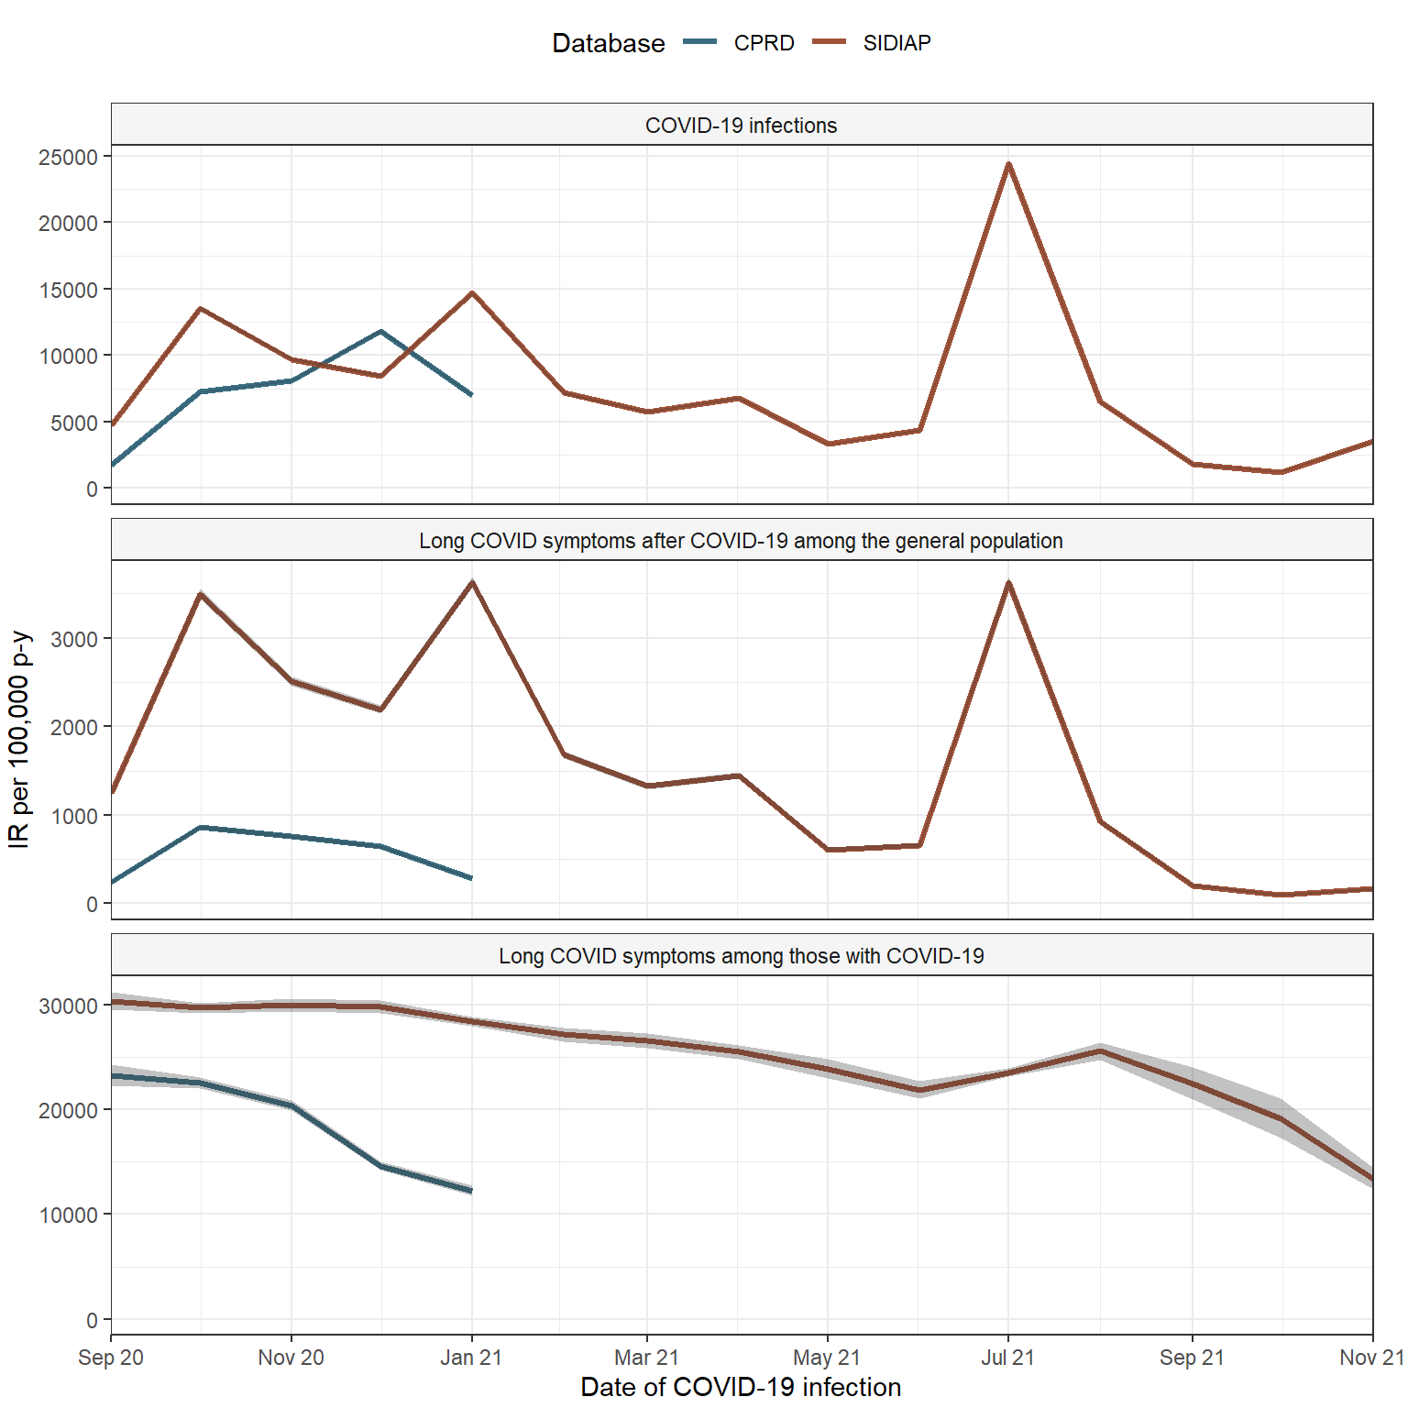
SIDIAP = Sistema d'Informació per al Desenvolupament de la Investigació en Atenció Primària, CPRD = Clinical Practice Research Datalink, IR = incidence rate, p-y = person years

Table S4: Incidence rates of COVID-19 and long COVID symptoms
Database | Cohort | COVID-19 test date (year-month-day) | Number of events | Person-years | Incidence rates per 1000 person-years with 95% CI
CPRD | COVID-19 infections | 2020-09-01 | 14490 | 843183 | 1718.5 [1690.6-1746.7]
CPRD | COVID-19 infections | 2020-10-01 | 62352 | 861067 | 7241.2 [7184.5-7298.3]
CPRD | COVID-19 infections | 2020-11-01 | 66552 | 824879 | 8068.1 [8006.9-8129.6]
CPRD | COVID-19 infections | 2020-12-01 | 100630 | 849090 | 11851.5 [11778.4-11925.0]
CPRD | COVID-19 infections | 2021-01-01 | 59807 | 854330 | 7000.5 [6944.5-7056.8]
CPRD | Long COVID symptoms after COVID-19 among the general population | 2020-09-01 | 2007 | 843538 | 237.9 [227.6-248.6]
CPRD |  | 2020-10-01 | 7453 | 863949 | 862.7 [843.2-882.5]
CPRD |  | 2020-11-01 | 6341 | 831606 | 762.5 [743.8-781.5]
CPRD |  | 2020-12-01 | 5514 | 856224 | 644.0 [627.1-661.2]
CPRD |  | 2021-01-01 | 2467 | 865953 | 284.9 [273.8-296.4]
CPRD | Long COVID symptoms among those with COVID-19 | 2020-09-01 | 2007 | 8620 | 23282.7 [22275.1-24324.1]
CPRD | Long COVID symptoms among those with COVID-19 | 2020-10-01 | 7453 | 33026 | 22567.4 [22057.9-23085.6]
CPRD | Long COVID symptoms among those with COVID-19 | 2020-11-01 | 6341 | 31059 | 20415.7 [19916.3-20924.5]
CPRD | Long COVID symptoms among those with COVID-19 | 2020-12-01 | 5514 | 37690 | 14629.8 [14246.1-15021.1]
CPRD | Long COVID symptoms among those with COVID-19 | 2021-01-01 | 2467 | 20102 | 12272.3 [11792.7-12766.3]
SIDIAP | COVID-19 infections | 2020-09-01 | 18786 | 397891 | 4721.4 [4654.1-4789.4]
SIDIAP | COVID-19 infections | 2020-10-01 | 55377 | 408593 | 13553.1 [13440.5-13666.5]
SIDIAP | COVID-19 infections | 2020-11-01 | 37986 | 392028 | 9689.6 [9592.4-9787.6]
SIDIAP | COVID-19 infections | 2020-12-01 | 34430 | 406809 | 8463.4 [8374.3-8553.3]
SIDIAP | COVID-19 infections | 2021-01-01 | 59492 | 404783 | 14697.2 [14579.4-14815.8]
SIDIAP | COVID-19 infections | 2021-02-01 | 26180 | 364866 | 7175.2 [7088.6-7262.7]
SIDIAP | COVID-19 infections | 2021-03-01 | 23340 | 406742 | 5738.3 [5664.9-5812.4]
SIDIAP | COVID-19 infections | 2021-04-01 | 26796 | 394110 | 6799.1 [6717.9-6881.0]
SIDIAP | COVID-19 infections | 2021-05-01 | 13450 | 407652 | 3299.4 [3243.9-3355.6]
SIDIAP | COVID-19 infections | 2021-06-01 | 17363 | 395800 | 4386.8 [4321.8-4452.6]
SIDIAP | COVID-19 infections | 2021-07-01 | 98891 | 404551 | 24444.6 [24292.5-24597.4]
SIDIAP | COVID-19 infections | 2021-08-01 | 26144 | 402411 | 6496.8 [6418.3-6576.1]
SIDIAP | COVID-19 infections | 2021-09-01 | 7201 | 395157 | 1822.3 [1780.5-1864.9]
SIDIAP | COVID-19 infections | 2021-10-01 | 4941 | 409215 | 1207.4 [1174.0-1241.6]
SIDIAP | COVID-19 infections | 2021-11-01 | 13992 | 395213 | 3540.4 [3481.9-3599.5]
SIDIAP | Long COVID symptoms after COVID-19 among the general population | 2020-09-01 | 4959 | 398447 | 1244.6 [1210.2-1279.7]
SIDIAP |  | 2020-10-01 | 14352 | 410848 | 3493.3 [3436.3-3550.9]
SIDIAP |  | 2020-11-01 | 9940 | 396524 | 2506.8 [2457.7-2556.6]
SIDIAP |  | 2020-12-01 | 8972 | 409775 | 2189.5 [2144.4-2235.3]
SIDIAP |  | 2021-01-01 | 14829 | 408647 | 3628.8 [3570.6-3687.7]
SIDIAP |  | 2021-02-01 | 6205 | 368859 | 1682.2 [1640.6-1724.6]
SIDIAP |  | 2021-03-01 | 5423 | 409123 | 1325.5 [1290.5-1361.3]
SIDIAP |  | 2021-04-01 | 5733 | 396244 | 1446.8 [1409.6-1484.8]
SIDIAP |  | 2021-05-01 | 2499 | 409786 | 609.8 [586.2-634.2]
SIDIAP |  | 2021-06-01 | 2627 | 396947 | 661.8 [636.7-687.6]
SIDIAP |  | 2021-07-01 | 14870 | 409558 | 3630.7 [3572.6-3689.6]
SIDIAP |  | 2021-08-01 | 3805 | 409323 | 929.6 [900.3-959.6]
SIDIAP |  | 2021-09-01 | 819 | 397130 | 206.2 [192.3-220.9]
SIDIAP |  | 2021-10-01 | 410 | 409896 | 100.0 [90.6-110.2]
SIDIAP |  | 2021-11-01 | 659 | 396005 | 166.4 [153.9-179.6]
 | Long COVID symptoms among those with COVID-19 | 2020-09-01 | 4982 | 16403 | 30372.9 [29535.2-31228.2]
 | Long COVID symptoms among those with COVID-19 | 2020-10-01 | 14411 | 48480 | 29725.4 [29242.0-30214.8]
 | Long COVID symptoms among those with COVID-19 | 2020-11-01 | 9963 | 33214 | 29996.7 [29410.5-30591.6]
 | Long COVID symptoms among those with COVID-19 | 2020-12-01 | 8975 | 30063 | 29853.5 [29239.0-30477.6]
 | Long COVID symptoms among those with COVID-19 | 2021-01-01 | 15005 | 52757 | 28441.5 [27988.2-28900.3]
 | Long COVID symptoms among those with COVID-19 | 2021-02-01 | 6311 | 23220 | 27178.8 [26512.3-27857.8]
 | Long COVID symptoms among those with COVID-19 | 2021-03-01 | 5479 | 20610 | 26584.5 [25885.2-27297.9]
 | Long COVID symptoms among those with COVID-19 | 2021-04-01 | 5790 | 22696 | 25510.8 [24857.9-26176.5]
 | Long COVID symptoms among those with COVID-19 | 2021-05-01 | 2519 | 10544 | 23890.5 [22966.5-24842.0]
 | Long COVID symptoms among those with COVID-19 | 2021-06-01 | 2708 | 12367 | 21896.4 [21079.4-22737.0]
 | Long COVID symptoms among those with COVID-19 | 2021-07-01 | 15070 | 63947 | 23566.3 [23191.6-23945.6]
 | Long COVID symptoms among those with COVID-19 | 2021-08-01 | 3840 | 15001 | 25597.6 [24794.3-26420.3]
 | Long COVID symptoms among those with COVID-19 | 2021-09-01 | 821 | 3655 | 22462.1 [20951.7-24052.6]
 | Long COVID symptoms among those with COVID-19 | 2021-10-01 | 410 | 2145 | 19114.6 [17309.0-21057.5]
 | Long COVID symptoms among those with COVID-19 | 2021-11-01 | 659 | 4927 | 13375.7 [12373.9-14437.1]

SIDIAP = Sistema d'Informació per al Desenvolupament de la Investigació en Atenció Primària, CPRD = Clinical Practice Research Datalink, IR = incidence rate, p-y = person years, 95% CI = 95% confidence intervals

Baseline characteristics after matching

Table S5: Baseline characteristics - COVID-19 infection vs first negative test matched 3:1
 | SIDIAP |  |  | CPRD
 | COVID-19 infection | First SARS-CoV-2 negative test | SMD | COVID-19 infections | First SARS-CoV-2 negative tests | SMD
N | 438,159 | 1,059,596 |  | 303,010 | 765,331
Days of follow-up (median [IQR]) | 365 [256, 365] | 358 [249, 365] | 0.095 | 152 [130, 188] | 151 [130, 188] | <0.001
Age (median [IQR]) | 45 [32, 58] | 45 [32, 58] | <0.001 | 41 [29, 54] | 41 [29, 54] | 0.001
Age, categories (%) |  |  | <0.001 |  |  | <0.001
≤34 | 131,754 (30.1) | 318,620 (30.1) |  | 112,429 (37.1) | 283,969 (37.1)
35-49 | 134,336 (30.7) | 324,864 (30.7) |  | 89,919 (29.7) | 227,114 (29.7)
50-64 | 99,763 (22.8) | 241,256 (22.8) |  | 73,682 (24.3) | 186,103 (24.3)
65-79 | 48,111 (11.0) | 116,346 (11.0) |  | 20,914 (6.9) | 52,824 (6.9)
≥80 | 24,195 (5.5) | 58,511 (5.5) |  | 6,066 (2.0) | 15,321 (2.0)
Sex, female (%) | 232,821 (53.1) | 555,243 (52.4) | 0.015 | 165,968 (54.8) | 434,410 (56.8) | 0.040
Test date period (%) |  |  | 0.001
Sep-Dec 2020 | 146,798 (33.5) | 355,000 (33.5) |  | 243.673 (80.4) | 615,460 (80.4)
Jan-Apr 2021 | 137,684 (31.4) | 333,003 (31.4) |  | 59,337 (19.6) | 149,871 (19.6) | <0.001
May-Aug 2021 | 127,496 (29.1) | 308,102 (29.1)
Sep-Dec 2021 | 26,181 (6.0) | 63,491 (6.0)
Vaccination status (%) |  |  | 0.085 |  |  | 0.027
Not vaccinated | 353,016 (80.6) | 831,172 (78.4) |  | 301,588 (99.5) | 762,992 (99.7)
First dose | 34,102 (7.8) | 75,205 (7.1) |  | 1,366 (0.5) | 2,224 (0.3)
Two doses | 50,640 (11.6) | 151,814 (14.3) |  | 56 (0.0) | 105 (0.0)
Three or more (booster) doses | 401 (0.1) | 1,405 (0.1) |  | <5 | 10 (0.0)
COVID-19 PCR test (%) | 233,565 (53.3) | 564,828 (53.3) | <0.001 | 283,916 (93.7) | 717,104 (93.7) | <0.001
Comorbidities (%)
Asthma | 33,021 (7.5) | 81,020 (7.6) | 0.004 | 48,151 (15.9) | 130,784 (17.1) | 0.032
Autoimmune disease | 8,278 (1.9) | 20,414 (1.9) | 0.003 | 6,098 (2.0) | 16,474 (2.2) | 0.010
COPD | 12,367 (2.8) | 32,731 (3.1) | 0.016 | 3,844 (1.3) | 12,318 (1.6) | 0.029
Dementia | 7,255 (1.7) | 10,090 (1.0) | 0.062 | 2,805 (0.9) | 5,854 (0.8) | 0.018
Diabetes | 39,514 (9.0) | 85,464 (8.1) | 0.034 | 21,064 (7.0) | 44,937 (5.9) | 0.044
Heart disease | 50,737 (11.6) | 120,362 (11.4) | 0.007 | 18,873 (6.2) | 47,572 (6.2) | 0.001
Cancer | 29,978 (6.8) | 77,464 (7.3) | 0.018 | 11,873 (3.9) | 32,380 (4.2) | 0.016
Hypertension | 82,005 (18.7) | 193,317 (18.2) | 0.012 | 38,940 (12.9) | 92,355 (12.1) | 0.024
Renal impairment | 19,866 (4.5) | 44,945 (4.2) | 0.014 | 9,985 (3.3) | 23,722 (3.1) | 0.011
SIDIAP = Sistema d'Informació per al Desenvolupament de la Investigació en Atenció Primària, CPRD = Clinical Practice Research Datalink, IQR = interquartile range, with q25 and q75 provided. SMD = standardized mean difference, COPD = Chronic Obstructive Pulmonary Disease

Rate Ratios - infections vs first negative test

Table S6: Rate Ratios of long COVID symptoms: COVID-19 infection vs first SARS-CoV-2 negative test - 90 days
Database | Symptom | N (Events)  COVID-19 infections | N (Events)  First negative tests | RR [with 95%CI]
SIDIAP | Altered smell taste | 726 | 371 | 4.73 [4.18;5.36]
SIDIAP | Dyspnoea | 3217 | 5755 | 1.35 [1.29;1.41]
SIDIAP | Menstrual problems | 2287 | 4516 | 1.22 [1.16;1.29]
SIDIAP | Cough | 6865 | 14384 | 1.15 [1.12;1.19]
SIDIAP | Fatigue malaise | 6647 | 14031 | 1.15 [1.11;1.18]
SIDIAP | Tachycardia | 1961 | 4136 | 1.15 [1.09;1.21]
SIDIAP | Headache | 7892 | 16730 | 1.14 [1.11;1.17]
SIDIAP | Memory issues | 939 | 1995 | 1.14 [1.05;1.23]
SIDIAP | Chest pain | 5884 | 12562 | 1.13 [1.10;1.17]
SIDIAP | Abdominal pain | 16021 | 34559 | 1.12 [1.10;1.14]
SIDIAP | Pins and needles sensation | 1779 | 3889 | 1.11 [1.05;1.17]
SIDIAP | Joint pain | 17441 | 38413 | 1.10 [1.08;1.12]
SIDIAP | Allergy | 6356 | 13953 | 1.10 [1.07;1.13]
SIDIAP | Blurred vision | 2292 | 5037 | 1.10 [1.05;1.16]
SIDIAP | Dizziness | 7182 | 16528 | 1.05 [1.02;1.08]
SIDIAP | Anxiety | 9499 | 22030 | 1.04 [1.02;1.07]
SIDIAP | Gastrointestinal issues | 8583 | 20197 | 1.03 [1.00;1.05]
SIDIAP | Sleep disorder | 5025 | 11929 | 1.02 [0.99;1.05]
SIDIAP | Neuralgia | 4407 | 10471 | 1.02 [0.98;1.05]
SIDIAP | Cognitive dysfunction | 1094 | 2616 | 1.01 [0.94;1.09]
SIDIAP | Intermittent fever | 4612 | 11214 | 0.99 [0.96;1.03]
SIDIAP | Tinnitus and hearing problems | 2840 | 6933 | 0.99 [0.95;1.03]
SIDIAP | Depression | 4064 | 10149 | 0.97 [0.93;1.00]
SIDIAP | Muscle spasms pain | 562 | 1520 | 0.89 [0.81;0.98]
CPRD | Altered smell taste | 201 | 85 | 5.97 [4.64;7.70]
CPRD | Fatigue malaise | 1887 | 3829 | 1.24 [1.18;1.32]
CPRD | Dyspnoea | 1860 | 4292 | 1.09 [1.04;1.16]
CPRD | Memory issues | 111 | 269 | 1.04 [0.84;1.30]
CPRD | Cognitive dysfunction | 73 | 178 | 1.04 [0.79;1.36]
CPRD | Pins and needles sensation | 225 | 550 | 1.03 [0.88;1.21]
CPRD | Tachycardia | 722 | 1848 | 0.99 [0.91;1.08]
CPRD | Chest pain | 1007 | 2611 | 0.97 [0.91;1.05]
CPRD | Allergy | 932 | 2463 | 0.96 [0.89;1.03]
CPRD | Tinnitus and hearing problems | 621 | 1656 | 0.95 [0.86;1.04]
CPRD | Dizziness | 821 | 2244 | 0.92 [0.85;1.00]
CPRD | Joint pain | 3771 | 10510 | 0.91 [0.87;0.94]
CPRD | Headache | 2240 | 6291 | 0.90 [0.86;0.94]
CPRD | Abdominal pain | 2647 | 7515 | 0.89 [0.85;0.93]
CPRD | Blurred vision | 115 | 327 | 0.89 [0.72;1.10]
CPRD | Menstrual problems | 652 | 1873 | 0.88 [0.80;0.96]
CPRD | Neuralgia | 500 | 1458 | 0.87 [0.78;0.96]
CPRD | Intermittent fever | 209 | 612 | 0.86 [0.74;1.01]
CPRD | Gastrointestinal issues | 1413 | 4176 | 0.85 [0.80;0.91]
CPRD | Sleep disorder | 759 | 2269 | 0.84 [0.78;0.92]
CPRD | Muscle spasms pain | 61 | 192 | 0.80 [0.60;1.07]
CPRD | Anxiety | 3414 | 10990 | 0.78 [0.76;0.82]
CPRD | Cough | 1681 | 5580 | 0.76 [0.72;0.80]
CPRD | Depression | 2754 | 9495 | 0.73 [0.70;0.76]

SIDIAP = Sistema d'Informació per al Desenvolupament de la Investigació en Atenció Primària, CPRD = Clinical Practice Research Datalink

Table S7: Rate Ratios of long COVID symptoms: COVID-19 infection vs first SARS-CoV-2 negative test - 28 days
Database | Symptom | N (Events)  COVID-19 infections | N (Events)  First negative tests | RR [with 95%CI]
SIDIAP | Altered smell taste | 857 | 505 | 4.10 [3.68;4.58]
SIDIAP | Dyspnoea | 4804 | 7493 | 1.55 [1.50;1.61]
SIDIAP | Tachycardia | 2816 | 5428 | 1.25 [1.20;1.31]
SIDIAP | Fatigue malaise | 8992 | 17702 | 1.23 [1.20;1.26]
SIDIAP | Menstrual problems | 2954 | 5832 | 1.22 [1.17;1.28]
SIDIAP | Memory issues | 1241 | 2466 | 1.22 [1.14;1.30]
SIDIAP | Cough | 8930 | 17909 | 1.21 [1.18;1.24]
SIDIAP | Chest pain | 7756 | 16100 | 1.16 [1.13;1.20]
SIDIAP | Headache | 10071 | 21406 | 1.14 [1.11;1.16]
SIDIAP | Pins and needles sensation | 2288 | 4849 | 1.14 [1.09;1.20]
SIDIAP | Blurred vision | 2977 | 6428 | 1.12 [1.07;1.17]
SIDIAP | Abdominal pain | 20254 | 43987 | 1.11 [1.10;1.13]
SIDIAP | Allergy | 8148 | 17844 | 1.10 [1.08;1.13]
SIDIAP | Joint pain | 21998 | 48497 | 1.10 [1.08;1.11]
SIDIAP | Anxiety | 12302 | 28213 | 1.05 [1.03;1.08]
SIDIAP | Dizziness | 9080 | 20898 | 1.05 [1.03;1.08]
SIDIAP | Sleep disorder | 6651 | 15398 | 1.04 [1.02;1.07]
SIDIAP | Cognitive dysfunction | 1460 | 3398 | 1.04 [0.98;1.10]
SIDIAP | Tinnitus and hearing problems | 3780 | 8869 | 1.03 [0.99;1.07]
SIDIAP | Gastrointestinal issues | 11054 | 26314 | 1.02 [0.99;1.04]
SIDIAP | Neuralgia | 5489 | 13321 | 1.00 [0.97;1.03]
SIDIAP | Depression | 5159 | 12802 | 0.97 [0.94;1.01]
SIDIAP | Intermittent fever | 5769 | 14556 | 0.96 [0.93;0.99]
SIDIAP | Muscle spasms pain | 720 | 1898 | 0.92 [0.84;1.00]
CPRD | Altered smell taste | 336 | 153 | 5.55 [4.58;6.71]
CPRD | Fatigue malaise | 3437 | 6342 | 1.37 [1.31;1.43]
CPRD | Dyspnoea | 3765 | 7559 | 1.26 [1.21;1.31]
CPRD | Memory issues | 192 | 414 | 1.17 [0.99;1.39]
CPRD | Chest pain | 2033 | 4462 | 1.15 [1.09;1.21]
CPRD | Tachycardia | 1367 | 3043 | 1.13 [1.06;1.21]
CPRD | Pins and needles sensation | 407 | 926 | 1.11 [0.99;1.25]
CPRD | Intermittent fever | 422 | 1035 | 1.03 [0.92;1.15]
CPRD | Tinnitus and hearing problems | 1111 | 2827 | 0.99 [0.93;1.06]
CPRD | Cognitive dysfunction | 122 | 315 | 0.98 [0.79;1.21]
CPRD | Allergy | 1435 | 3735 | 0.97 [0.91;1.03]
CPRD | Dizziness | 1445 | 3819 | 0.96 [0.90;1.02]
CPRD | Joint pain | 6185 | 16398 | 0.95 [0.93;0.98]
CPRD | Menstrual problems | 1161 | 3127 | 0.94 [0.88;1.00]
CPRD | Gastrointestinal issues | 2680 | 7250 | 0.93 [0.89;0.98]
CPRD | Blurred vision | 205 | 559 | 0.93 [0.79;1.09]
CPRD | Abdominal pain | 4662 | 12757 | 0.92 [0.89;0.95]
CPRD | Headache | 3666 | 10079 | 0.92 [0.88;0.95]
CPRD | Neuralgia | 849 | 2337 | 0.92 [0.85;0.99]
CPRD | Sleep disorder | 1472 | 4072 | 0.91 [0.86;0.97]
CPRD | Cough | 3501 | 9880 | 0.90 [0.86;0.93]
CPRD | Anxiety | 5576 | 16975 | 0.83 [0.81;0.85]
CPRD | Muscle spams pain | 96 | 294 | 0.82 [0.66;1.04]
CPRD | Depression | 4275 | 14270 | 0.76 [0.73;0.78]

SIDIAP = Sistema d'Informació per al Desenvolupament de la Investigació en Atenció Primària, CPRD = Clinical Practice Research Datalink, CI = confidence intervals
Note: Symptoms with <5 events were not considered.

Table S8: Baseline characteristics: first COVID-19 infection vs re-infections matched 1:3
 | SIDIAP |  |  | CPRD
 | First infection | Re-infections | SMD | First infection | Re-infections | SMD
N | 39,492 | 13,253 |  | 2,126 | 709
Days of follow-up (median [IQR]) | 326 [244, 365] | 306 [234, 365] | 0.093 | 141 [127, 173] | 142 [127, 173] | 0.002
Age (median [IQR]) | 46 [30, 63] | 46 [30, 63] | 0.001 | 47 [31, 58] | 46 [31, 59] | 0.001
Age, categories (%) |  |  | <0.001 |  |  | <0.001
≤34 | 12,492 (31.6) | 4,192 (31.6) |  | 681 (32.0) | 227 (32.0)
35-49 | 9,619 (24.4) | 3,228 (24.4) |  | 513 (24.1) | 171 (24.1)
50-64 | 8,054 (20.4) | 2,703 (20.4) |  | 588 (27.6) | 196 (27.6)
65-79 | 4,175 (10.6) | 1,401 (10.6) |  | 207 (9.7) | 69 (9.7)
≥80 | 5,152 (13.0) | 1,729 (13.0) |  | 138 (6.5) | 46 (6.5)
Sex, female (%) | 24,297 (61.5) | 8,084 (61.0) | 0.011 | 1,419.3 (66.8) | 470 (66.3) | 0.010
Test date period (%) |  |  | 0.005
Sep-Dec 2020 | 9,625 (24.4) | 3,230 (24.4) |  | 1562 (73.5) | 521 (73.5)
Jan-Apr 2021 | 11,945 (30.2) | 3,995 (30.1) |  | 564 (26.5) | 188 (26.5) | <0.001
May-Aug 2021 | 14,122 (35.8) | 4,734 (35.7)
Sep-Dec 2021 | 3,799 (9.6) | 1,294 (9.8)
Vaccination status (%) |  |  | 0.151 |  |  | 0.162
Not vaccinated | 29,401 (74.4) | 9,655 (72.9) |  | 2,107 (99.1) | 687 (96.9)
First dose | 3,675 (9.3) | 1,803 (13.6) |  | 19 (0.9) | 20 (2.8)
Two doses | 6,378 (16.1) | 1,766 (13.3) |  | <5 | <5
Three or more (booster) doses | 39 (0.1) | 29 (0.2)
COVID-19 PCR test (%) | 26,214 (66.4) | 8,797 (66.4) | <0.001 | 1,673 (78.7) | 558 (78.7) | <0.001
Comorbidities (%)
Asthma | 3,687 (9.3) | 1,165 (8.8) | 0.019 | 438 (20.6) | 141 (19.9) | 0.018
Autoimmune disease | 1,094 (2.8) | 370 (2.8) | 0.001 | 64 (3.0) | 15 (2.1) | 0.055
COPD | 1,836 (4.6) | 670 (5.1) | 0.019 | 82 (3.9) | 26 (3.7) | 0.010
Dementia | 1,361 (3.4) | 789 (6.0) | 0.119 | 48 (2.3) | 28 (3.9) | 0.098
Diabetes | 4,851 (12.3) | 1,643 (12.4) | 0.003 | 218 (10.2) | 92 (13.0) | 0.085
Heart disease | 7,013 (17.8) | 2,392 (18.0) | 0.008 | 246 (11.6) | 89 (12.6) | 0.030
Cancer | 3,967 (10.0) | 1,350 (10.2) | 0.005 | 126 (5.9) | 40 (5.6) | 0.012
Hypertension | 10,397 (26.3) | 3,266 (24.6) | 0.039 | 416 (19.6) | 138 (19.5) | 0.002
Renal impairment | 3,389 (8.6) | 1,279 (9.7) | 0.037 | 139 (6.5) | 58 (8.2) | 0.063
SIDIAP = Sistema d'Informació per al Desenvolupament de la Investigació en Atenció Primària, CPRD = Clinical Practice Research Datalink, IQR = interquartile range, with q25 and q75 provided. COPD = Chronic Obstructive Pulmonary Disease, SMD = Standardized Mean Difference

Figure S3: Rate Ratios of long COVID symptoms: COVID-19 infection vs first SARS-CoV-2 negative test - 28 days
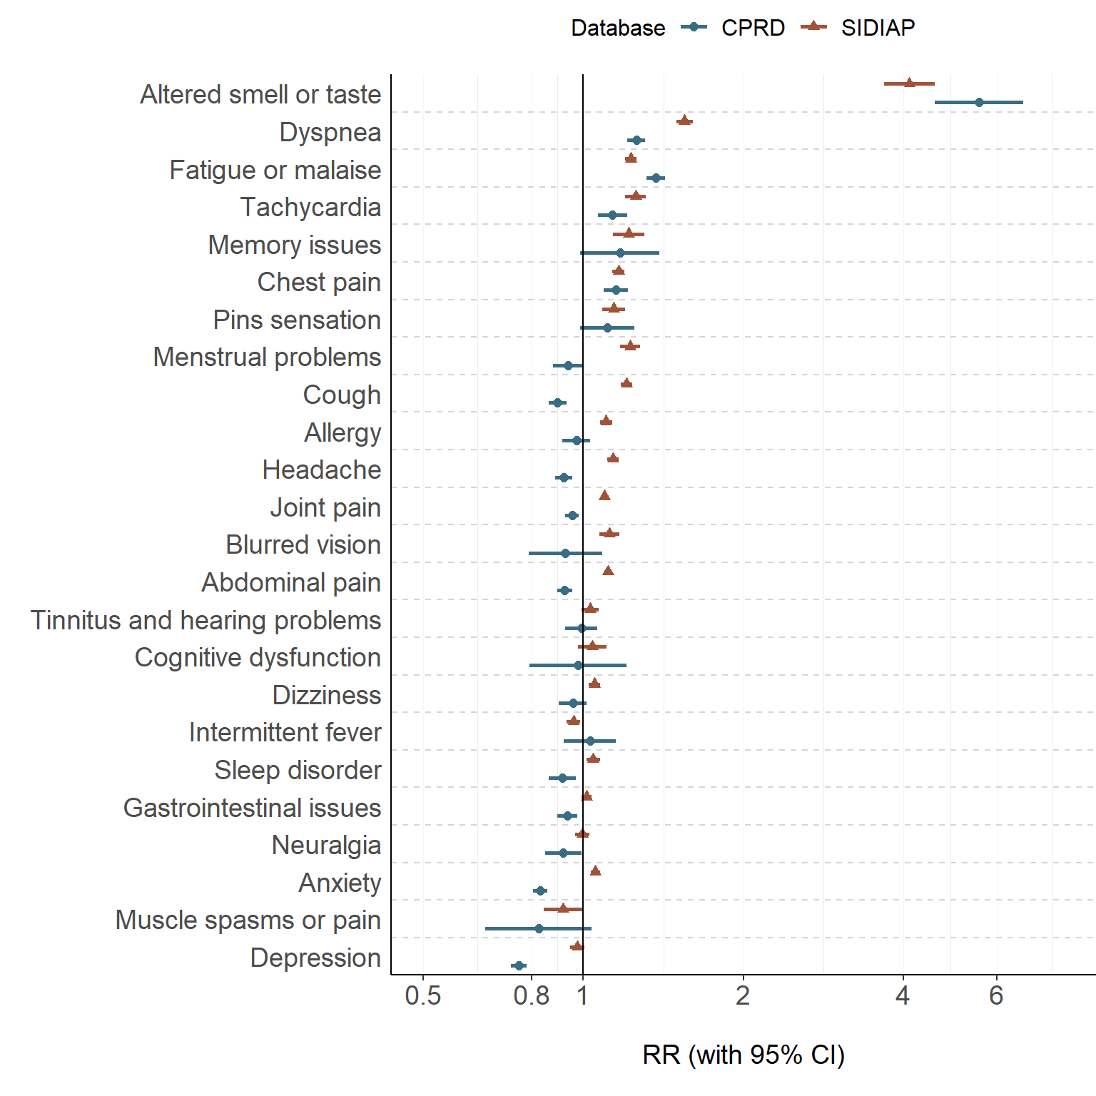
SIDIAP = Sistema d'Informació per al Desenvolupament de la Investigació en Atenció Primària, CPRD = Clinical Practice Research Datalink, RR = Rate Ratio, 95% CI = 95% confidence intervals

Rate Ratios - infections vs all negative tests

Table S9: Rate ratios of long COVID symptoms, COVID-19 infection vs all SARS-CoV-2 negative tests - 90 days
Database | Symptom | N (Events)  COVID-19 infections | N (Events)  all negative tests | RR [with 95%CI]
SIDIAP | Altered smell taste | 726 | 479 | 4.08 [3.63;4.58]
SIDIAP | Dyspnoea | 3218 | 7531 | 1.15 [1.10;1.20]
SIDIAP | Memory issues | 939 | 2223 | 1.14 [1.05;1.23]
SIDIAP | Menstrual problems | 2287 | 5919 | 1.04 [0.99;1.09]
SIDIAP | Pins and needles sensation | 1779 | 4725 | 1.01 [0.96;1.07]
SIDIAP | Joint pain | 17441 | 47614 | 0.99 [0.97;1.00]
SIDIAP | Cognitive dysfunction | 1094 | 2981 | 0.99 [0.92;1.06]
SIDIAP | Fatigue malaise | 6644 | 18264 | 0.98 [0.95;1.01]
SIDIAP | Tachycardia | 1960 | 5373 | 0.98 [0.93;1.03]
SIDIAP | Chest pain | 5884 | 16354 | 0.97 [0.94;1.00]
SIDIAP | Allergy | 6354 | 17947 | 0.95 [0.93;0.98]
SIDIAP | Abdominal pain | 16022 | 45479 | 0.95 [0.93;0.96]
SIDIAP | Headache | 7892 | 22654 | 0.94 [0.91;0.96]
SIDIAP | Blurred vision | 2292 | 6534 | 0.94 [0.90;0.99]
SIDIAP | Tinnitus and hearing problems | 2840 | 8118 | 0.94 [0.90;0.98]
SIDIAP | Cough | 6865 | 20051 | 0.92 [0.90;0.95]
SIDIAP | Dizziness | 7182 | 21390 | 0.90 [0.88;0.93]
SIDIAP | Sleep disorder | 5030 | 15083 | 0.90 [0.87;0.93]
SIDIAP | Anxiety | 9499 | 29102 | 0.88 [0.86;0.90]
SIDIAP | Neuralgia | 4408 | 13519 | 0.88 [0.85;0.91]
SIDIAP | Gastrointestinal issues | 8584 | 26631 | 0.87 [0.85;0.89]
SIDIAP | Muscle spams pain | 562 | 1788 | 0.85 [0.77;0.93]
SIDIAP | Depression | 4064 | 13453 | 0.81 [0.78;0.84]
SIDIAP | Intermittent fever | 4616 | 16192 | 0.77 [0.74;0.79]
CPRD | Altered smell taste | 201 | 99 | 5.58 [4.39;7.10]
CPRD | Fatigue malaise | 1889 | 4627 | 1.12 [1.06;1.18]
CPRD | Dyspnoea | 1862 | 4951 | 1.03 [0.98;1.09]
CPRD | Memory issues | 111 | 297 | 1.03 [0.83;1.28]
CPRD | Pins sensation | 225 | 653 | 0.95 [0.81;1.10]
CPRD | Chest pain | 1008 | 2984 | 0.93 [0.87;1.00]
CPRD | Tachycardia | 722 | 2185 | 0.91 [0.84;0.99]
CPRD | Tinnitus and hearing problems | 621 | 1904 | 0.90 [0.82;0.98]
CPRD | Blurred vision | 115 | 361 | 0.88 [0.71;1.08]
CPRD | Cognitive dysfunction | 73 | 228 | 0.88 [0.68;1.15]
CPRD | Allergy | 933 | 2983 | 0.86 [0.80;0.93]
CPRD | Joint pain | 3772 | 12341 | 0.84 [0.81;0.87]
CPRD | Dizziness | 821 | 2676 | 0.84 [0.78;0.91]
CPRD | Abdominal pain | 2650 | 8861 | 0.82 [0.79;0.86]
CPRD | Headache | 2242 | 7534 | 0.82 [0.78;0.86]
CPRD | Menstrual problems | 652 | 2196 | 0.82 [0.75;0.89]
CPRD | Neuralgia | 500 | 1699 | 0.81 [0.73;0.89]
CPRD | Muscle spasm or pain | 61 | 207 | 0.81 [0.61;1.08]
CPRD | Sleep disorder | 759 | 2604 | 0.80 [0.74;0.87]
CPRD | Gastrointestinal issues | 1414 | 4927 | 0.79 [0.74;0.84]
CPRD | Intermittent fever | 210 | 746 | 0.77 [0.66;0.90]
CPRD | Anxiety | 3414 | 13044 | 0.72 [0.69;0.75]
CPRD | Cough | 1680 | 6703 | 0.69 [0.65;0.73]
CPRD | Depression | 2754 | 11209 | 0.68 [0.65;0.70]

SIDIAP = Sistema d'Informació per al Desenvolupament de la Investigació en Atenció Primària, CPRD = Clinical Practice Research Datalink, CI = confidence intervals

Figure S4: Rate Ratios of long COVID symptoms, COVID-19 infection vs all SARS-CoV-2 negative tests - 90 days
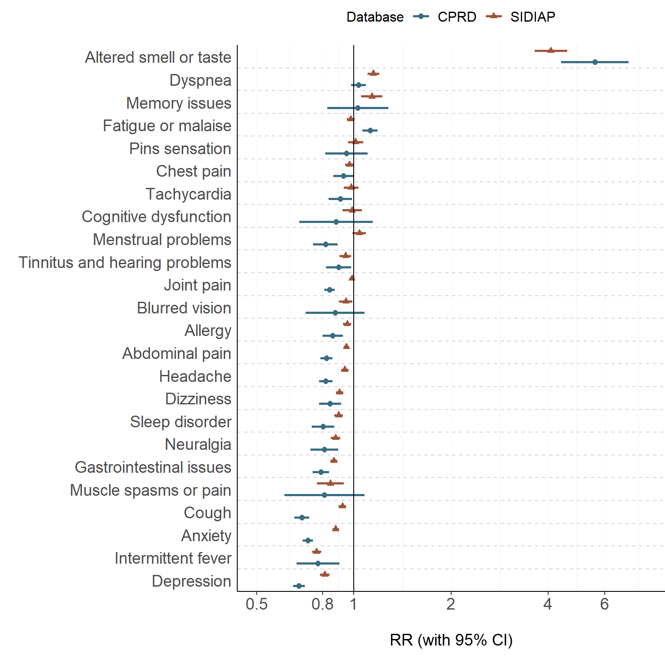
SIDIAP = Sistema d'Informació per al Desenvolupament de la Investigació en Atenció Primària, CPRD = Clinical Practice Research Datalink, RR = Rate ratio, 95% CI = 95% confidence intervals

Table S10: Rate ratio of long COVID symptoms, COVID-19 infection vs all SARS-CoV-2 negative tests - 28 days
Database | Symptom | N (Events)  COVID-19 infections | N (Events)  first negative tests | Relative risk [with 95%CI]
SIDIAP | Altered smell taste | 857 | 680 | 3.39 [3.07;3.75]
SIDIAP | Dyspnoea | 4808 | 10731 | 1.21 [1.17;1.25]
SIDIAP | Memory issues | 1241 | 3328 | 1.00 [0.94;1.07]
SIDIAP | Tachycardia | 2818 | 7722 | 0.98 [0.94;1.02]
SIDIAP | Fatigue malaise | 8999 | 25112 | 0.96 [0.94;0.99]
SIDIAP | Menstrual problems | 2955 | 8318 | 0.96 [0.92;1.00]
SIDIAP | Cough | 8942 | 25982 | 0.93 [0.90;0.95]
SIDIAP | Pins sensation | 2290 | 6634 | 0.93 [0.89;0.97]
SIDIAP | Blurred vision | 2978 | 8663 | 0.92 [0.89;0.96]
SIDIAP | Chest pain | 7761 | 22842 | 0.91 [0.89;0.94]
SIDIAP | Joint pain | 22006 | 65532 | 0.90 [0.89;0.92]
SIDIAP | Allergy | 8151 | 24391 | 0.90 [0.88;0.92]
SIDIAP | Abdominal pain | 20266 | 61474 | 0.89 [0.87;0.90]
SIDIAP | Headache | 10082 | 30644 | 0.89 [0.87;0.90]
SIDIAP | Tinnitus and hearing problems | 3783 | 11666 | 0.87 [0.84;0.90]
SIDIAP | Cognitive dysfunction | 1462 | 4586 | 0.86 [0.81;0.91]
SIDIAP | Dizziness | 9082 | 28868 | 0.85 [0.83;0.87]
SIDIAP | Sleep disorder | 6659 | 21404 | 0.84 [0.81;0.86]
SIDIAP | Anxiety | 12318 | 40337 | 0.82 [0.81;0.84]
SIDIAP | Neuralgia | 5494 | 18450 | 0.80 [0.78;0.83]
SIDIAP | Gastrointestinal issues | 11064 | 37366 | 0.80 [0.78;0.81]
SIDIAP | Muscle spasm pain | 721 | 2449 | 0.79 [0.73;0.86]
SIDIAP | Depression | 5162 | 18523 | 0.75 [0.73;0.77]
SIDIAP | Intermittent fever | 5775 | 21693 | 0.72 [0.70;0.74]
CPRD | Altered smell taste | 336 | 181 | 5.10 [4.26;6.12]
CPRD | Fatigue malaise | 3440 | 7748 | 1.22 [1.17;1.27]
CPRD | Dyspnoea | 3771 | 8900 | 1.17 [1.12;1.21]
CPRD | Memory issues | 192 | 486 | 1.09 [0.92;1.28]
CPRD | Chest pain | 2034 | 5268 | 1.06 [1.01;1.12]
CPRD | Tachycardia | 1367 | 3706 | 1.01 [0.95;1.08]
CPRD | Pins sensation | 407 | 1112 | 1.01 [0.90;1.13]
CPRD | Tinnitus and hearing problems | 1112 | 3292 | 0.93 [0.87;0.99]
CPRD | Intermittent fever | 422 | 1305 | 0.89 [0.80;0.99]
CPRD | Allergy | 1437 | 4515 | 0.88 [0.82;0.93]
CPRD | Joint pain | 6191 | 19495 | 0.87 [0.85;0.90]
CPRD | Menstrual problems | 1161 | 3707 | 0.86 [0.81;0.92]
CPRD | Dizziness | 1445 | 4624 | 0.86 [0.81;0.91]
CPRD | Sleep disorder | 1472 | 4733 | 0.86 [0.81;0.91]
CPRD | Blurred vision | 205 | 657 | 0.86 [0.73;1.00]
CPRD | Gastrointestinal issues | 2683 | 8654 | 0.85 [0.82;0.89]
CPRD | Neuralgia | 849 | 2753 | 0.85 [0.79;0.92]
CPRD | Cognitive dysfunction | 123 | 397 | 0.85 [0.70;1.04]
CPRD | Abdominal pain | 4664 | 15250 | 0.84 [0.81;0.87]
CPRD | Headache | 3669 | 12247 | 0.82 [0.79;0.85]
CPRD | Cough | 3504 | 11925 | 0.81 [0.78;0.84]
CPRD | Muscle spasm or pain | 96 | 327 | 0.81 [0.64;1.01]
CPRD | Anxiety | 5576 | 20378 | 0.75 [0.73;0.77]
CPRD | Depression | 4277 | 17030 | 0.69 [0.67;0.71]

SIDIAP = Sistema d'Informació per al Desenvolupament de la Investigació en Atenció Primària, CPRD = Clinical Practice Research Datalink, CI = confidence intervals

Figure S5: Rate ratios of long COVID symptoms, COVID-19 infection vs all SARS-CoV-2 negative tests - 28 days
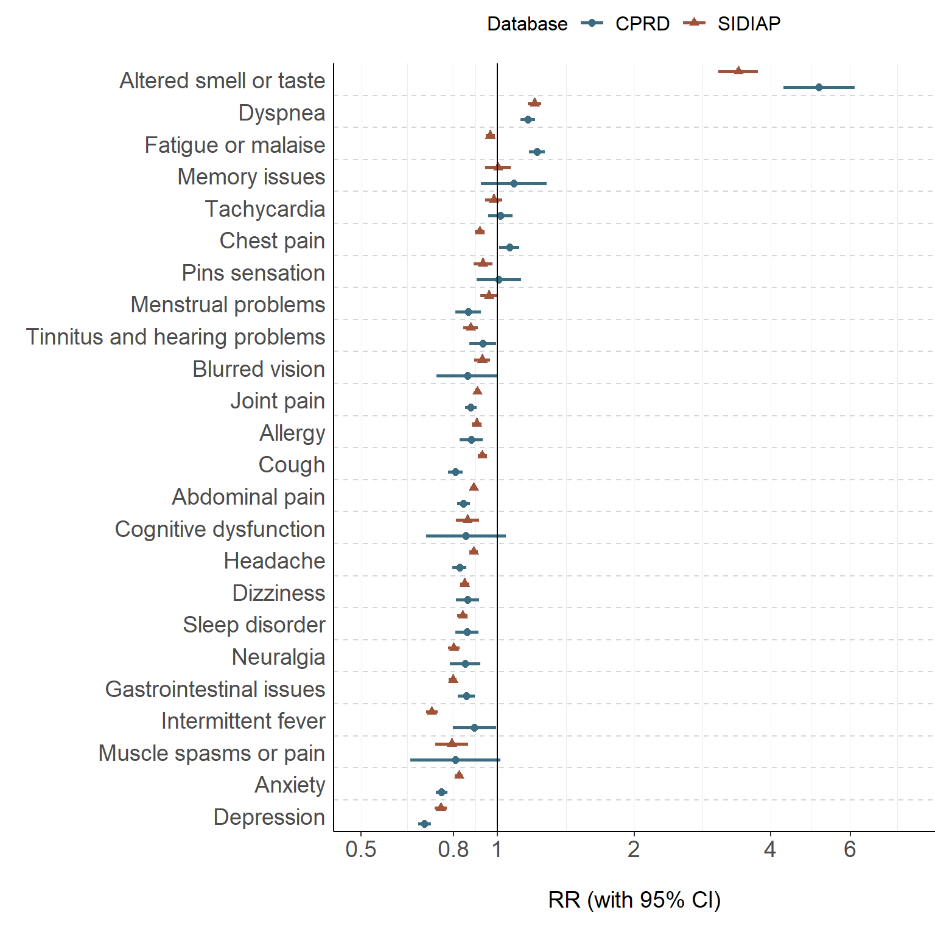
SIDIAP = Sistema d'Informació per al Desenvolupament de la Investigació en Atenció Primària, CPRD = Clinical Practice Research Datalink, RR = Rate ratios, 95% CI = 95% confidence intervals

Rate Ratios - re-infections vs first infection

Table S11: Rate ratio of long-COVID symptoms, first infection vs re-infection - 90 days
Database | Symptom | N (Events)  Re-infections | N (Events)  First infections | RR [with 95%CI]
SIDIAP | Altered smell taste | 16 | 241 | 0.20 [0.12;0.33]
SIDIAP | Menstrual problems | 76 | 785 | 0.29 [0.23;0.36]
SIDIAP | Joint pain | 580 | 5904 | 0.29 [0.27;0.32]
SIDIAP | Muscle spasms pain | 23 | 220 | 0.31 [0.20;0.48]
SIDIAP | Tinnitus and hearing problems | 107 | 986 | 0.32 [0.27;0.39]
SIDIAP | Headache | 292 | 2728 | 0.32 [0.28;0.36]
SIDIAP | Abdominal pain | 576 | 5433 | 0.32 [0.29;0.34]
SIDIAP | Neuralgia | 167 | 1502 | 0.33 [0.28;0.39]
SIDIAP | Fatigue malaise | 255 | 2302 | 0.33 [0.29;0.38]
SIDIAP | Anxiety | 368 | 3306 | 0.33 [0.30;0.37]
SIDIAP | Cognitive dysfunction | 54 | 474 | 0.34 [0.26;0.45]
SIDIAP | Allergy | 235 | 2078 | 0.34 [0.29;0.39]
SIDIAP | Cough | 286 | 2534 | 0.34 [0.30;0.38]
SIDIAP | Dizziness | 267 | 2372 | 0.34 [0.30;0.38]
SIDIAP | Blurred vision | 91 | 780 | 0.35 [0.28;0.43]
SIDIAP | Tachycardia | 77 | 658 | 0.35 [0.28;0.44]
SIDIAP | Memory issues | 39 | 319 | 0.36 [0.26;0.51]
SIDIAP | Pins sensation | 69 | 576 | 0.36 [0.28;0.46]
SIDIAP | Chest pain | 244 | 2007 | 0.36 [0.32;0.41]
SIDIAP | Depression | 186 | 1496 | 0.37 [0.32;0.43]
SIDIAP | Intermittent fever | 201 | 1628 | 0.37 [0.32;0.43]
SIDIAP | Sleep disorder | 218 | 1744 | 0.37 [0.32;0.43]
SIDIAP | Dyspnoea | 150 | 1119 | 0.40 [0.34;0.47]
SIDIAP | Gastrointestinal issues | 413 | 3024 | 0.41 [0.37;0.45]
CPRD | Anxiety | 7 | 253 | 0.08 [0.04;0.17]
CPRD | Depression | 9 | 218 | 0.12 [0.06;0.24]
CPRD | Dyspnoea | 7 | 162 | 0.13 [0.06;0.27]
CPRD | Abdominal pain | 8 | 179 | 0.13 [0.07;0.27]
CPRD | Joint pain | 18 | 310 | 0.17 [0.11;0.28]
CPRD | Headache | 11 | 164 | 0.20 [0.11;0.37]
CPRD | Gastrointestinal issues | 8 | 104 | 0.23 [0.11;0.47]
CPRD | Cough | 13 | 118 | 0.33 [0.19;0.58]
CPRD | Tinnitus and hearing problems | 6 | 51 | 0.35 [0.15;0.82]

SIDIAP = Sistema d'Informació per al Desenvolupament de la Investigació en Atenció Primària, CPRD = Clinical Practice Research Datalink, CI = confidence intervals
Note: Symptoms with <5 events were not considered.

Table S12: Rate ratios of long-COVID symptoms, first infection vs re-infection - 28 days
Database | Symptom | N (Events)  Re-infections | N (Events)  First infections | RR [with 95%CI]
SIDIAP | Altered smell taste | 22 | 245 | 0.27 [0.17;0.41]
SIDIAP | Joint pain | 741 | 6317 | 0.35 [0.32;0.38]
SIDIAP | Muscle spasms pain | 32 | 256 | 0.37 [0.26;0.54]
SIDIAP | Fatigue malaise | 344 | 2785 | 0.37 [0.33;0.41]
SIDIAP | Anxiety | 478 | 3807 | 0.37 [0.34;0.41]
SIDIAP | Menstrual problems | 107 | 841 | 0.38 [0.31;0.46]
SIDIAP | Tinnitus and hearing problems | 144 | 1130 | 0.38 [0.32;0.45]
SIDIAP | Allergy | 300 | 2354 | 0.38 [0.34;0.43]
SIDIAP | Cognitive dysfunction | 75 | 573 | 0.39 [0.31;0.50]
SIDIAP | Cough | 372 | 2825 | 0.39 [0.35;0.44]
SIDIAP | Sleep disorder | 270 | 2043 | 0.39 [0.35;0.45]
SIDIAP | Abdominal pain | 760 | 5877 | 0.39 [0.36;0.41]
SIDIAP | Headache | 381 | 2873 | 0.40 [0.36;0.44]
SIDIAP | Tachycardia | 110 | 807 | 0.41 [0.33;0.50]
SIDIAP | Blurred vision | 127 | 922 | 0.41 [0.34;0.49]
SIDIAP | Dizziness | 360 | 2642 | 0.41 [0.36;0.45]
SIDIAP | Chest pain | 310 | 2257 | 0.41 [0.36;0.46]
SIDIAP | Pins and needles sensation | 92 | 643 | 0.43 [0.34;0.53]
SIDIAP | Dyspnoea | 210 | 1466 | 0.43 [0.37;0.49]
SIDIAP | Depression | 237 | 1621 | 0.44 [0.38;0.50]
SIDIAP | Neuralgia | 223 | 1524 | 0.44 [0.38;0.50]
SIDIAP | Intermittent fever | 271 | 1817 | 0.44 [0.39;0.50]
SIDIAP | Gastrointestinal issues | 543 | 3446 | 0.47 [0.43;0.51]
SIDIAP | Memory issues | 59 | 357 | 0.49 [0.37;0.65]
CPRD | Fatigue malaise | 7 | 195 | 0.11 [0.05;0.23]
CPRD | Anxiety | 10 | 254 | 0.12 [0.06;0.22]
CPRD | Chest pain | 5 | 105 | 0.14 [0.06;0.35]
CPRD | Abdominal pain | 11 | 234 | 0.14 [0.08;0.26]
CPRD | Depression | 11 | 207 | 0.16 [0.09;0.29]
CPRD | Sleep disorder | 5 | 77 | 0.19 [0.08;0.48]
CPRD | Allergy | 6 | 77 | 0.23 [0.10;0.53]
CPRD | Joint pain | 24 | 291 | 0.25 [0.16;0.37]
CPRD | Cough | 18 | 200 | 0.27 [0.17;0.43]
CPRD | Headache | 15 | 163 | 0.28 [0.16;0.47]
CPRD | Dyspnoea | 18 | 192 | 0.28 [0.17;0.45]
CPRD | Tinnitus and hearing problems | 6 | 51 | 0.35 [0.15;0.82]
CPRD | Gastrointestinal issues | 17 | 135 | 0.38 [0.23;0.62]
CPRD | Intermittent fever | 5 | 29 | 0.52 [0.20;1.33]

SIDIAP = Sistema d'Informació per al Desenvolupament de la Investigació en Atenció Primària, CPRD = Clinical Practice Research Datalink, CI = confidence intervals
Note: Symptoms with <5 events were not considered.

Figure S6: Rate ratio of long-COVID symptoms, first infection vs re-infection - 28 days
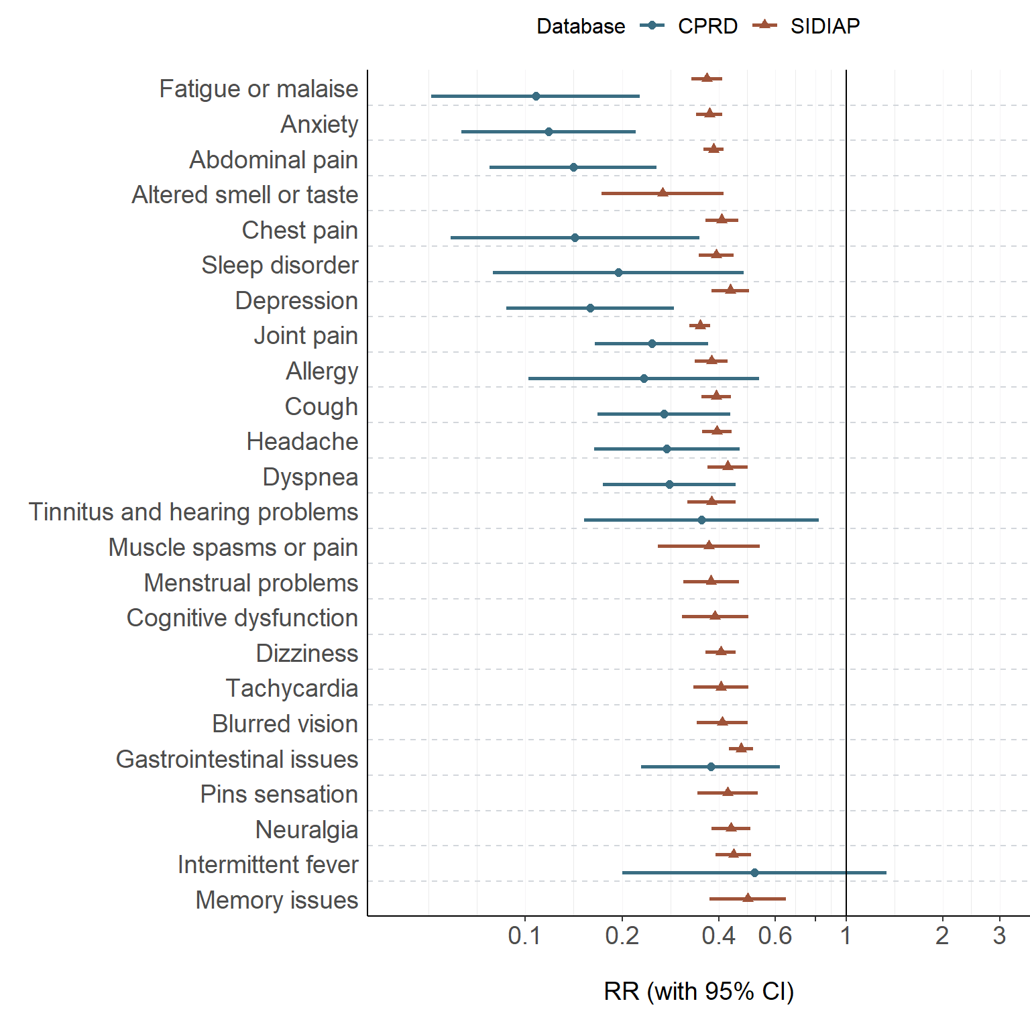
SIDIAP = Sistema d'Informació per al Desenvolupament de la Investigació en Atenció Primària, CPRD = Clinical Practice Research Datalink, RR = Rate ratio, 95% CI = 95% confidence intervals

