Supplemental Information

Experimental
Synthesis of Li_{6.5}La₃Zr_{1.5}Ta_{0.5}O₁₂ (LLZTO)
The LLZTO powder was prepared by a modified Pechini sol-gel method.¹ Specifically, 2.96 g of LiNO₃ (99.99%, Sigma), 7.14 g of La(NO₃)₃∙6H₂O (99.99%, Sigma) and 2.80g of ZrO(NO₃)₂∙6H₂O (99.99%, Sigma) were each dissolved separately in 100 ml of deionised H₂O. The respective solutions were each warmed to 60 ºC to promote dissolution. 0.99 g of TaCl₅ (99.99%, Sigma) was dissolved in 10 ml of ethanol. All the aforementioned solutions were then combined to form a precursor solution. 3.2 g of ethylene glycol and 10.84 g of citric acid were dissolved in 100 ml of H₂O. This chelating agent solution was combined with the precursor solution and then heated at 90 °C until all the water evaporated, and a white gel formed. The gel was ground and heated at 400 °C under air for 10 h to burn off the organic compounds. The resulting powder was ground again and re-heated at 900 °C in air for 12 h to form LLZTO. The LLZTO powder was then heated at 800 °C for 1 h under argon and transferred to an Ar-filled glovebox without exposure to air.

Disk formation (spark plasma sintering) and sealing
The as-prepared LLZTO was loaded into a graphite die set inside an Ar-filled glovebox, with all sides protected by graphite foil. The die set was then transferred without air exposure to a spark plasma sintering machine. The LLZTO was initially cold pressed then heated at a ramp rate of 100 °C min⁻¹ to 1150 °C and the temperature was held constant for 15 min under an applied pressure. The pressure was slowly released as the sample was cooled to room temperature at a rate of 30 °C min⁻¹. To remove graphite and other surface contaminants, the LLZTO disk surfaces were dry polished with P400 and P1200 SiC papers and the disks were heated under Ar at 800 ºC for 30 min. This procedure has previously been shown to be effective for removing major contaminants from the surface of LLZTO.²⁻⁶ It produced dense LLZTO disks (thickness: 2-2.5 mm, diameter: 1.4 cm, 98 % (± 1.1 %) of theoretical density); the tap density of the LLZTO powder was determined to be 5.345 g cm⁻³ using a micromeritics AccuPyc II 1340 gas pycnometer and the envelop density of the cylindrical disks after polishing was calculated using a mass value determined by weighing and a volume calculated from the diameter and thickness of the disk. Powder X-ray diffraction (PXRD) and Inductively coupled plasma (ICP) analysis confirmed the LLZTO disks were Li_{6.5}La₃Zr_{1.5}Ta_{0.5}O₁₂, Figure S1.^{7,8} Fourier-transform infrared (FTIR) spectroscopy, Figure S2, showed no evidence of any peaks in the regions for Li₂CO₃ and LiOH on the LLZTO surface after cleaning. All subsequent manipulations were performed in an Ar-filled glovebox. In order to maintain a well-defined surface area for the electrochemical measurements, the LLZTO disks (thickness: 2-2.5 mm) were cut using an ultrasonic knife into smaller disks (0.5-1 cm²) and each small disk was subsequently set into a ring of polypropylene (PP). To achieve this, the LLZTO disk was aligned in the centre of a PP ring (inner diameter 18 mm, outer diameter 40 mm) and the gap between PP ring and the LLZTO disk was filled by PP particles. Using a hotplate, the temperature was slowly increased until the PP particles melted and when a satisfactory junction between the materials was apparent, the plastic was cooled to room temperature at a rate of 10 °C min⁻¹, such that a sealed LLZTO disk was obtained.

Cell design and impedance
Electrochemical impedance spectroscopy (EIS) was performed in a 4-electrode cell to exclude any effect from the electrode/liquid electrolyte interface, Figure S1(a). In this cell, all electrodes were made of partially oxidised Li_{x}FePO₄ (LFP). The two-phase LFP has a fixed potential of 3.45 V versus Li⁺/Li. LFP is chemically stable in the liquid electrolyte and does not breakdown to form soluble products. Other non-blocking electrodes, such as lithium, could form electrolyte degradation products which can diffuse to, and contaminate, the solid electrolyte/liquid electrolyte interface and would add unnecessary complication to a fundamental study. The liquid electrolyte was LP30 (LiPF₆ in ethylene carbonate (EC): dimethyl carbonate (DMC) (1:1 v/v), BASF battery-grade; H₂O < 15 ppm, HF < 50 ppm). The respective compartments of the cell were sealed by O-rings, which were pressed, by means of a C clamp, onto the PP ring encapsulating the LLZTO disk. After assembly, LP30 was added into the two chambers of the cell and impedance measurements were taken over a frequency range of 1 MHz to 0.1 Hz. The permeability of the disk was evaluated to ensure no leakage of electrolyte between the two liquid compartments of the cell. This was carried out by filling one side of the cell with DMC containing ferrocene and the other side with only DMC; after 150 h, ultraviolet–visible spectra collected from the second compartment showed no evidence of ferrocene. During the whole measurement period, the cell was placed in a grounded Faraday cage inside the glovebox. The Nyquist impedance of LLZTO in LP30 is shown in Figure S1(b) and the the equivalent circuit describing the electrical processes anticipated for the cell is shown in the inset of Figure S1(b); it is composed of three parallel RC elements and a resistor connected in series. R_{LE}, represents the resistance of the LP30 liquid electrolyte, while R_{SE}^{g} and R_{SE}^{gb} represent the bulk and grain boundary resistances of the LLZTO disk, respectively, and R_{SE/LE} is the resistance at the ceramic/liquid electrolyte interface. CPE1 and CPE2 represent the capacitances of the bulk and grain boundaries of the ceramic respectively, and CPE3 is that of the interface between the solid and liquid electrolyte. The Nyquist plot has two distinct semicircles, where the high-frequency semi-circle is only partially resolved. The low-frequency semi-circle dominates the impedance and is reflective of a capacitance equal to 4.43 µF cm⁻²; this is consistent with a solid/liquid interface previous reported and hence this semi-circle is ascribed to the SE/LE interface. Although only partially visible, the high-frequency intercept of the low-frequency semi-circle corresponds to the sum of the liquid electrolyte, ceramic bulk (grain) and grain boundary resistances (R_{LE}+R_{SE}^{g}+R_{SE}^{gb}). To confirm the correct assignment of the semicircles, Table S1, R_{LE} and R_{SE}^{g}+R_{SE}^{gb} were evaluated by two independent experiments. To isolate the contributions from R_{SE}^{g}+R_{SE}^{gb} (in the absence of R_{LE} and R_{SE/LE}), 2-electrode EIS, using Au blocking electrodes, was performed on a pristine LLZTO disk. The corresponding Nyquist plot, shown in Figure S4, did not contain the low-frequency semi-circle ascribed to R_{SE/LE} and only contained one partially resolved semi-circle with a resistance of 430 Ω, which was consistent with intragrain and grain boundary resistances (R_{SE}^{g}+R_{SE}^{gb}) commonly observed in LLZTO.⁹ By recording the impedance spectrum of the 4-electrode cell without the LLZTO disk separating the two compartments, the resistance of the LP30 electrolyte (R_{LE}) was determined to be 380 Ω. Together, the total resistance of the solid electrolyte (R_{SE}^{g}+R_{SE}^{gb}) plus the liquid electrolyte (R_{LE}) was 810 Ω, which is in accordance with the high-frequency intercept of the low frequency semicircle in Figure S1(b), confirming that the low-frequency impedance is indeed due to R_{LE}+R_{SE}^{g}+R_{SE}^{gb}, establishing that the low-frequency semicircle is associated with to R_{SE/LE}.

Characterization of the LLZTO disks
Following immersion in LP30, LLZTO disks were rinsed with DMC and were dried before further characterizations. All preparations were performed inside an Ar-filled glovebox (<1 ppm O₂ and <1 ppm H₂O) and all samples were transferred to the spectrometer using an airtight vacuum transfer case. X-ray photoelectron spectroscopy (XPS) measurements were performed using a Thermo Scientific K-Alpha XPS instrument equipped with a microfocussed monochromated Al X-ray source, operated at 12 keV. Scanning electron microscopy (SEM) images were obtained using an FE-SEM (Zeiss-Merlin) instrument with an air-sensitive sample holder. Images of the LLZTO surface were acquired from a top-down view and from a cross-sectional view. To access the cross-section, the disks were cut using an ultrasonic knife. PXRD was carried out on samples in an air-sensitive holder using a Rigaku X-ray diffractometer employing Cu K_{α} radiation. FTIR spectra were recorded on a Thermo Infrared spectrometer (Nicolet 6700) in an inert atmosphere glovebox in attenuated total reflectance (ATR) mode. Time of flight secondary ion mass spectrometry (TOF-SIMS) analysis and depth profiling was conducted with a TOF-SIMS5-Qtac100 LEIS instrument with a Bismuth primary-ion source and a Caesium sputter gun. High-resolution transmission electron microscopy (HRTEM) images were acquired using a Jeol-3000F microscope at an acceleration voltage of 300 kV. LLZTO powder was dispersed in LP30 electrolyte and sonicated for 5 min. After 10 h of exposure, the LLZTO powder was washed with DMC three times and then dispersed onto a copper TEM grid. All preparations were performed inside an Ar-filled glovebox and the sample was transferred with an airtight holder. Solid state magic angle spinning (MAS) nuclear magnetic resonance (NMR) measurements were performed at 9.4 T (ν₀(¹⁹F) = 376.2 MHz), using a Bruker Avance III HD spectrometer. A Bruker 4 mm HFXY probe was utilized to generate MAS frequencies (ν_{R}) between 8 – 12 kHz. The ¹⁹F spectra were referenced to the secondary reference PTFE_{(s)} (δ_{iso} = −123.4 ppm).¹⁰ A 100 kHz (^{π}/₂) pulse was determined for the ¹⁹F experiments, to prevent any possible saturation of the signal an excessive recycle delay of 30 minutes was used throughout.

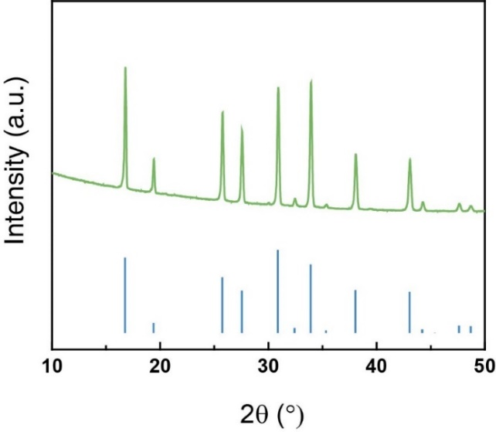
Figure S1. PXRD pattern of a pristine LLZTO disk (green) and a reference pattern for LLZTO (blue).^{7,8}

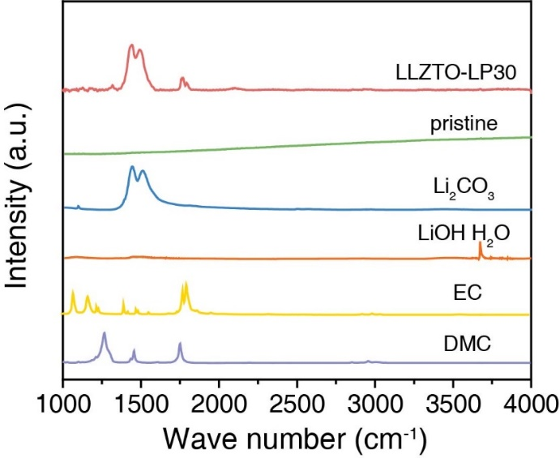

Figure S2. FTIR spectra of LLZTO disks obtained in ATR mode and reference spectra for expected impurities. Pristine refers to the disk after surface treatment to remove surface impurities. LLZTO-LP30 refers to the disk after exposure to LP30 for 150 h. Peaks around 1500 cm⁻¹ correspond to Li₂CO₃ and peaks around 1750 cm⁻¹ in the carbonyl region correspond to both solvent decomposition fragments and organic carbonates originating from the LP30 electrolyte and the DMC used for washing.
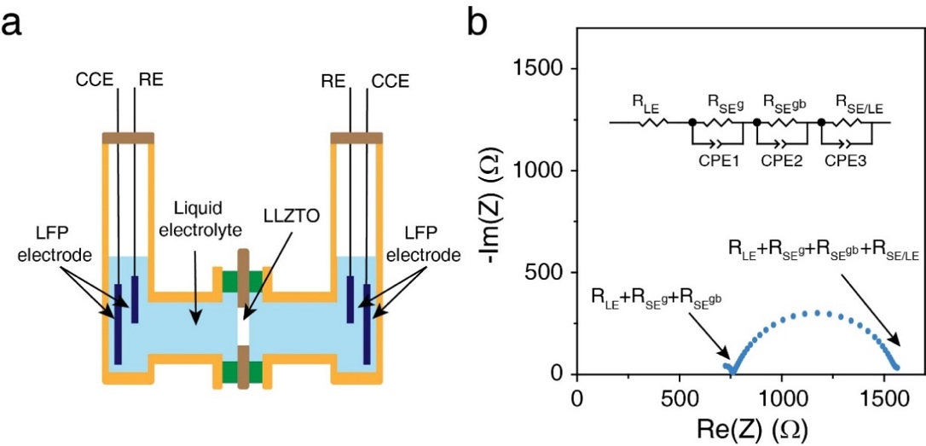
Figure S3. (a) Schematic of the 4-electrode cell used in these studies. The ceramic electrolyte separates two compartments each filled with the liquid electrolyte and each containing a CCE and a RE and (b) a Nyquist plot for the cell over the frequency range 0.1 Hz to 1 MHz. Inset shows the equivalent circuit used in this study, where; R_{LE} is the liquid electrolyte resistance, R_{SE}^{g} and R_{SE}^{gb} are the respective bulk (grain) and grain boundary resistances of the ceramic electrolyte, and R_{SE/LE} is the solid electrolyte/liquid electrolyte interfacial resistance. The constant phase elements, CPE1 and CPE2 are the respective capacitances associated with the bulk and grain boundary regions of the solid electrolyte and CPE3 is the capacitance of the SE/LE interface.

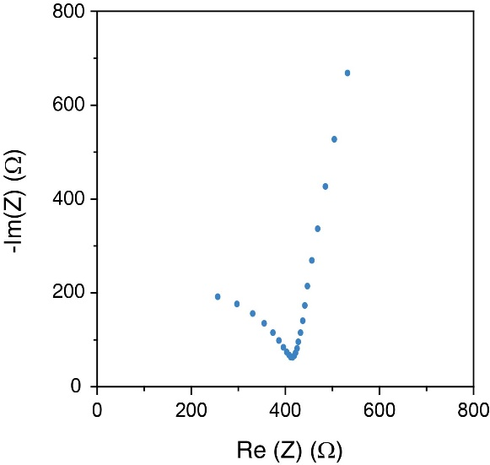
Figure S4. Nyquist plot of LLZTO with symmetric Au blocking electrodes over the frequency range 0.1 Hz to 1 MHz. The low-frequency spike is due to the blocking electrodes and represents the double-layer capacitance of the Au/LLZTO interface. The high-frequency semicircle represents the Li⁺ ion conductivity in the grain and grain boundary of LLZTO. The intercept of the high-frequency semicircle corresponds to the total resistance of 430 Ω for a disk with a surface area of 0.55 cm².
Table S1. Resistance and capacitance data for the Nyquist plot in Figure S1b.
Component
R_{SE/LE} | 800.7 ± 1.779 Ω
Q_{SE/LE} | (4.398 ± 0.064) × 10⁻⁶ S s^{-α}
α_{SE/LE} | 0.815 ± 0.002
C_{SE/LE} | (1.220 ± 0.045) × 10⁻⁶ F

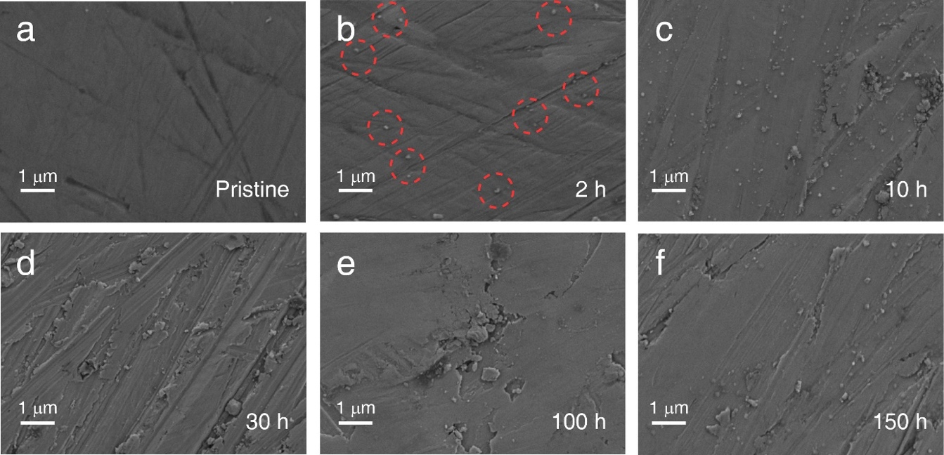

Figure S5. SEM: top down view images of the LLZTO disk surface after immersion in LP30 for various times: (a) pristine, (b) 2 h, (c) 10 h, (d) 30 h, (e) 100 h & (f) 150 h. Scale bar is 1 µm. Cross sectional view images after (g) 10 h, (h) 20 h & (i) 150 h.

Figure S6. TEM of LLZTO particles after exposure to LP30 for 10 h and after washing with DMC.

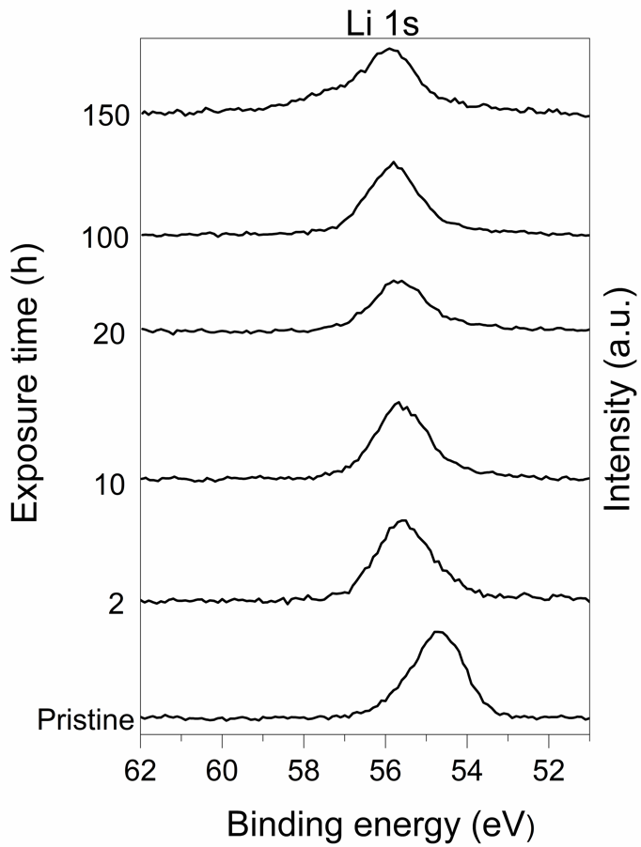

Figure S7. Li 1s XPS spectra of LLZTO disks after exposure to LP30 for 0, 2, 10, 20, 100 and 150 h.

Figure S8. ¹⁹F MAS NMR spectrum of LLZTO powder after exposure to LP30 for 10 h. The sideband manifold for LiF_{(s)} reference powder gives good agreement with the LLZTO post-exposure resonance. The minor resonance at −77 ppm is attributed to LiPF₆, with the lack of sideband manifold due to the high point symmetry of the fluorine environments.¹¹

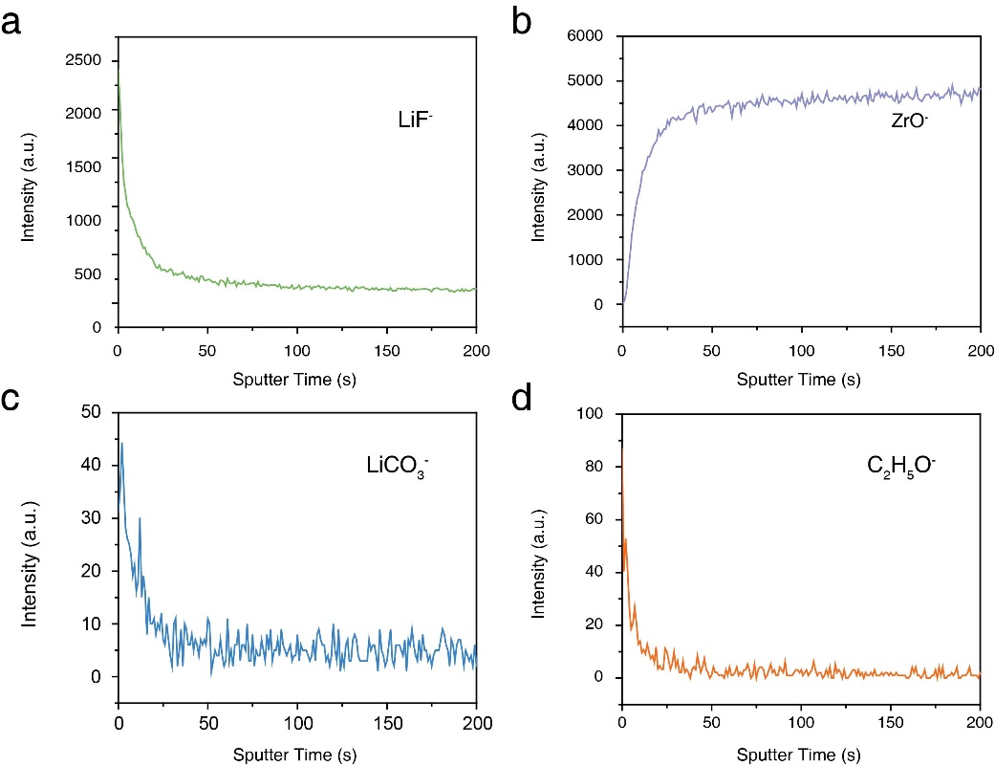
Figure S9. Depth profiling of TOF-SIMS analysis of the LLZTO disk after immersion in LP30 for 150 h.
References
1 Janani, N. et al. Synthesis of cubic Li₇La₃Zr₂O₁₂ by modified sol–gel process. Ionics 17, 575-580,(2011).
2 Sharafi, A. et al. Impact of air exposure and surface chemistry on Li–Li₇La₃Zr₂O₁₂ interfacial resistance. Journal of Materials Chemistry A 5, 13475-13487,(2017).
3 Sharafi, A. et al. Surface Chemistry Mechanism of Ultra-Low Interfacial Resistance in the Solid-State Electrolyte Li₇La₃Zr₂O₁₂. Chemistry of Materials 29, 7961-7968,(2017).
4 Cheng, L. et al. Effect of surface microstructure on electrochemical performance of garnet solid electrolytes. ACS Appl Mater Interfaces 7, 2073-2081,(2015).
5 Han, F. et al. Interphase Engineering Enabled All-Ceramic Lithium Battery. Joule 2, 497-508,(2018).
6 Cheng, L. et al. The origin of high electrolyte-electrode interfacial resistances in lithium cells containing garnet type solid electrolytes. Phys Chem Chem Phys 16, 18294-18300,(2014).
7 Buschmann, H. et al. Structure and dynamics of the fast lithium ion conductor "Li₇La₃Zr₂O₁₂". Phys Chem Chem Phys 13, 19378-19392,(2011).
8 Li, Y., Han, J., Vogel, S. C. & Wang, C. The reaction of Li_{6.5}La₃Zr_{1.5}Ta_{0.5}O₁₂ with water. Solid State Ionics 269, 57-61,(2015).
9 Yoon, S. A., Oh, N. R., Yoo, A. R., Lee, H. G. & Lee, H. C. Preparation and Characterization of Ta-substituted Li₇La₃Zr_{2-x}O₁₂ Garnet Solid Electrolyte by Sol-Gel Processing. Journal of the Korean Ceramic Society 54, 278-284,(2017).
10 Harris, R. K., Becker, E. D., Cabral de Menezes, S. M., Goodfellow, R. & Granger, P. NMR Nomenclature: Nuclear Spin Properties and Conventions for Chemical Shifts. IUPAC Recommendations 2001. Solid State Nucl Magn Reson 22, 458-483,(2002).
11 Jin, Y. et al. Understanding Fluoroethylene Carbonate and Vinylene Carbonate Based Electrolytes for Si Anodes in Lithium Ion Batteries with NMR Spectroscopy. J Am Chem Soc 140, 9854-9867,(2018).

