Charge separated states and singlet oxygen generation of Mono and Bis Adducts of C₆₀ and C₇₀
Panagiotis Dallasª, Gregory Rogersª, Ben Reid ^{b}, Robert A. Taylor ^{b}, Hisanori Shinohara ^{c}, G. Andrew D. Briggs ª and Kyriakos Porfyrakis*ª
ª Department of Materials, University of Oxford, Oxford OX1 3PH, UK.
^{b} Department of Physics, Clarendon Laboratory, University of Oxford, Oxford OX1 3PH, UK.
^{c} Department of Chemistry & Institute for Advanced Research, Nagoya University, Nagoya 464-8602, Japan

- Chapter 1: Spectroscopy and calculation of quantum yields
- Chapter 2: Mass spectroscopy
- Chapter 3: Singlet oxygen supression in toluene
- Chapter 4: NMR spectroscopy
- Chapter 5: PL spectra in chloroform
- Chapter 6: Residual fitting data

Supporting information section:
-Chapter 1: Spectroscopy and calculation of quantum yields
Figure S1. Photoluminescence spectra for the 1-carboxaldehyde (black line), mono-adduct (blue line) and bis-adduct (red line), of C₆₀ in toluene. Excitation wavelength: 345 nm
Figure S2. Absorbance (a) and emission under 335 nm excitation (b) of pristine pyrene in ethanol (red) and toluene (black).

Calculation of quantum yields.
Pyrene in ethanol has a well-known quantum yield of 0.65. The integration of the absorbance took place from 325 to 346 nm and the excitation for recording the fluorescence was 335 nm. Same procedure was followed for a toluene solution. In Figure S3 are the integrated peaks for the ethanol solution and below are the absorbance range for all samples:
Pyrene in toluene: 325-346 nm
Pyrene in ethanol: 325-346 nm
Pristine C₆₀: 510-549 nm (exc. 520 nm)
Pristine C₇₀: 428-533 (exc. 520 nm)
C₆₀-mono: 325-346 nm (exc. 335 nm), 424-444 (exc. 434 nm), 510-549 nm (exc. 520 nm)
C₇₀-mono: 325-346 nm (exc. 335 nm), 428-533 (exc. 520 nm)

Figure S3. Integrated absorbance peak for pyrene in ethanol.

Figure S4. Blank toluene indicating the inelastic scattering peaks
Figure S5. a) C₆₀ and b) C₇₀ under different excitation wavelengths: 455 nm-488 nm. The peaks at 527 and 573 nm are from Raman scattering.

Figure S6. Photoluminescence for the mono adducts of a) C₆₀ and b) C₇₀ under different excitations.

Figure S7. Photoluminescence for the bis adducts of a) C₆₀ and b) C₇₀, under different excitations.

Figure S8. Photoluminescence of the C₆₀-bis adducts in two different concentration under excitation of 488 nm.

- Chapter 2: Mass spectroscopy
Figure S9. Mass spec of C₆₀ bis adduct (black) and C₇₀ bis adduct (red).

- Chapter 3: Singlet oxygen supression in toleune

Figure S10. Excitation dependent photoluminescence maps for C₆₀ and C₇₀ in toluene.

- Chapter 4: NMR spectroscopy

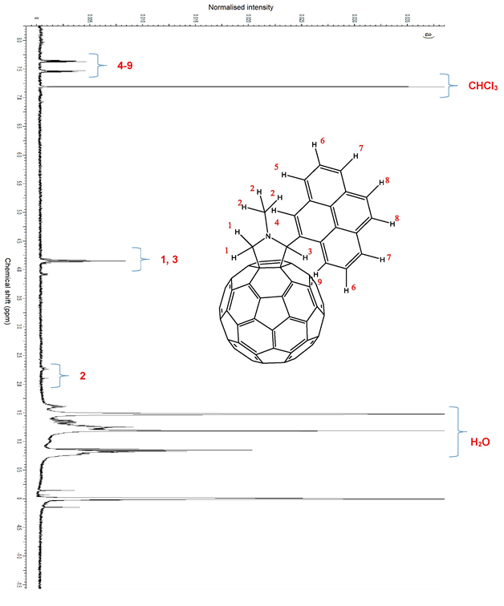
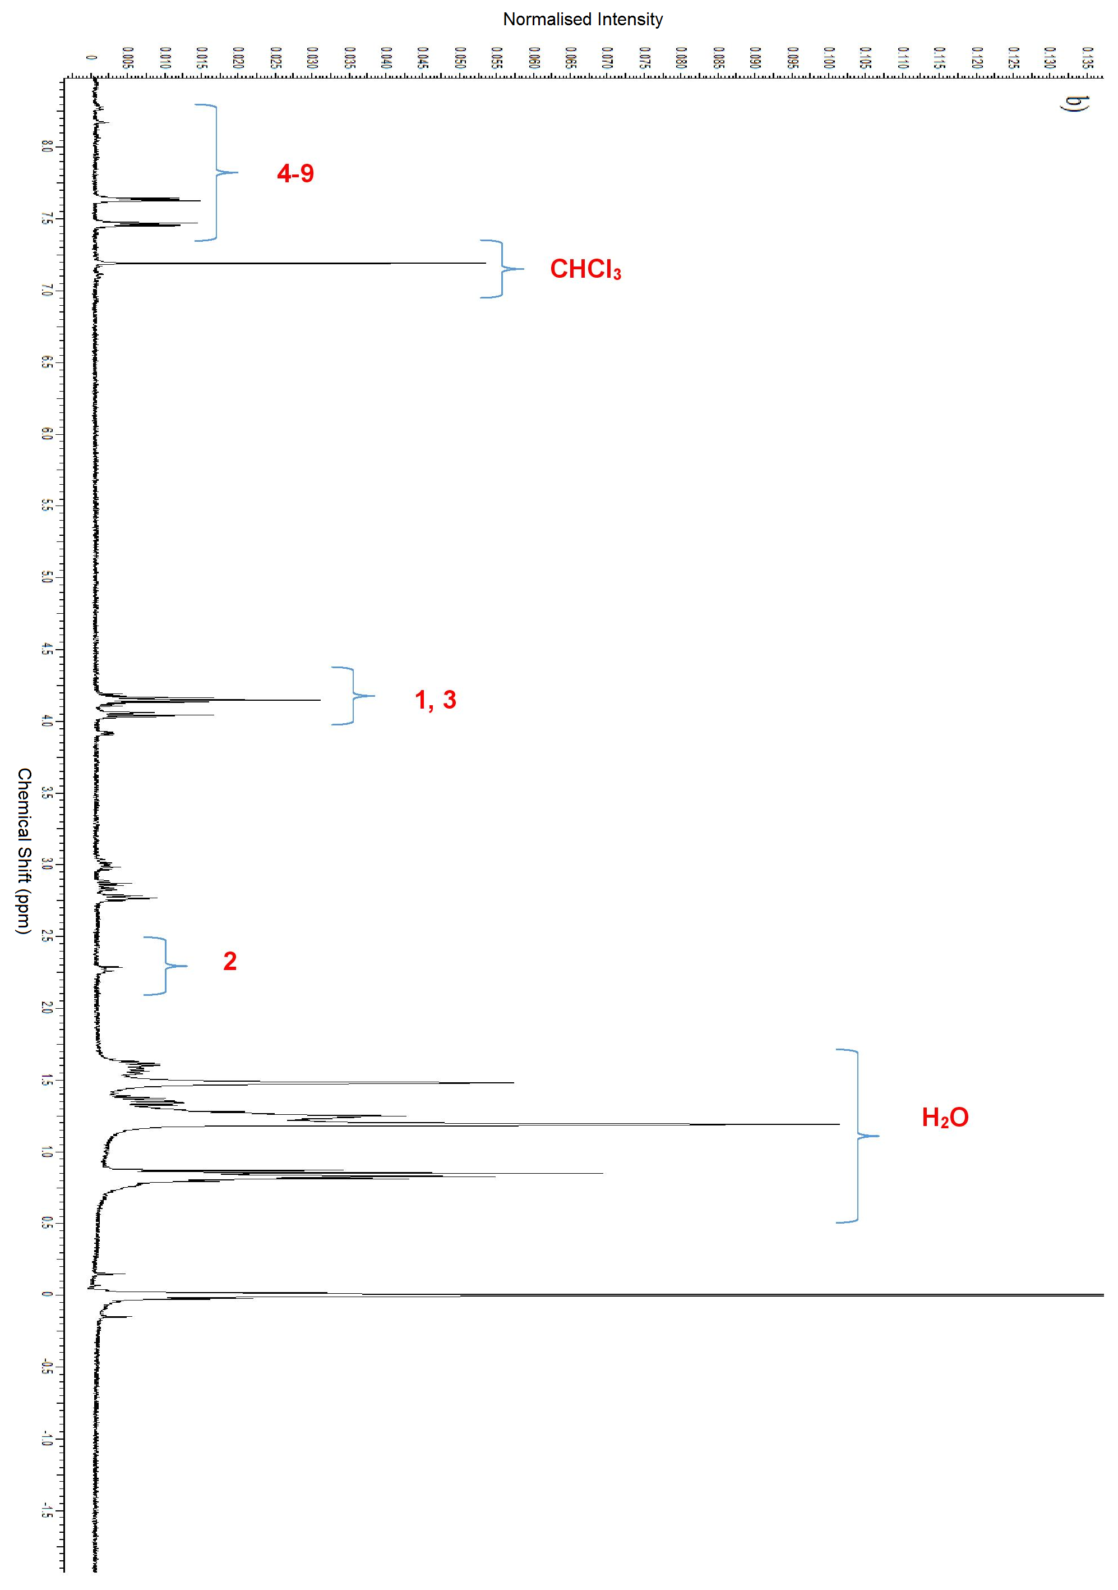
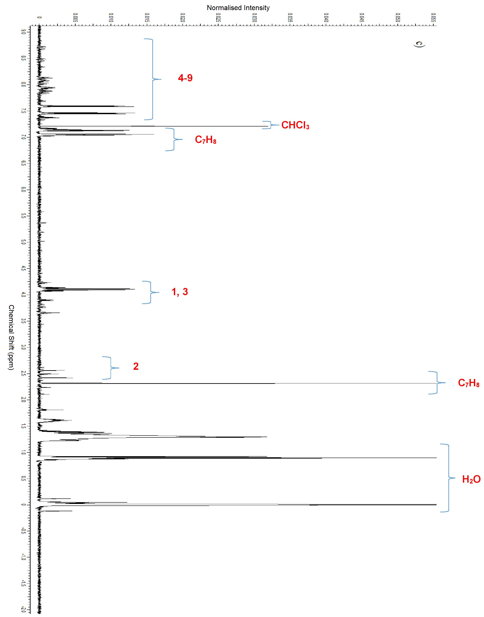
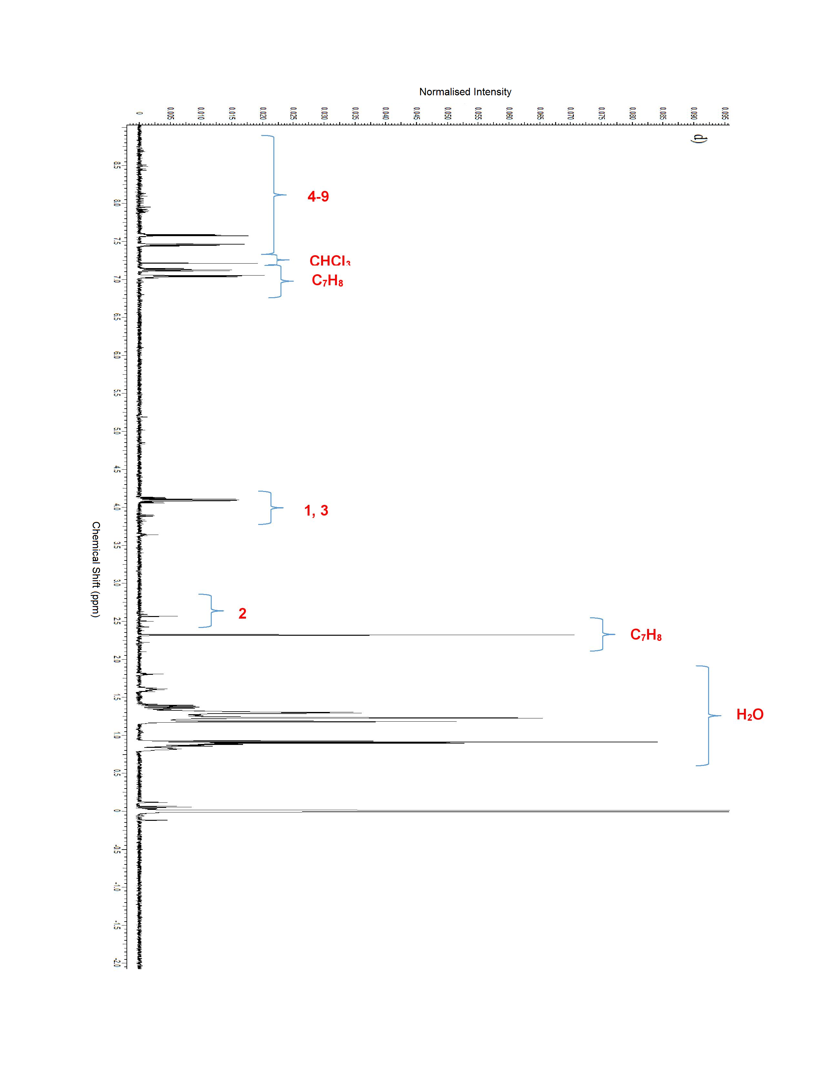
Figure S11. ¹H NMR (400 MHz, CS₂/CDCl₃) spectra of a) C₆₀ mono δ/ppm: 0.5-2 water, 2.25 (w, 3H), 3.9 (w, 1H), 4.15 (m, 2H), 7.4-7.7 (m, 9H), 7.2 CHCl₃. b) C₆₀ bis δ/ppm: 0.5-2 water, 2.25 (w, 3H), 3.9 (w, 1H), 4.15 (m, 2H), 7.4-8.5 (m, 9H), 7.2 CHCl₃. c) C₇₀ mono δ/ppm: 0.5-2 water, 2.26 toluene, 2.5 (w, 3H), 3.9 (w, 1H), 4.15 (m, 2H), 7.4-9.0 (m, 9H), 7.0-7.15 toluene, 7.2 CHCl₃. d) C₇₀ bis adduct δ/ppm: 0.5-2 water, 2.26 toluene, 2.5 (w, 3H), 3.9 (w, 1H), 4.15 (m, 2H), 7.4-9.0 (m, 9H), 7.0-7.15 toluene, 7.2 CHCl₃.

-Chapter 5: PL spectra in chloroform
a)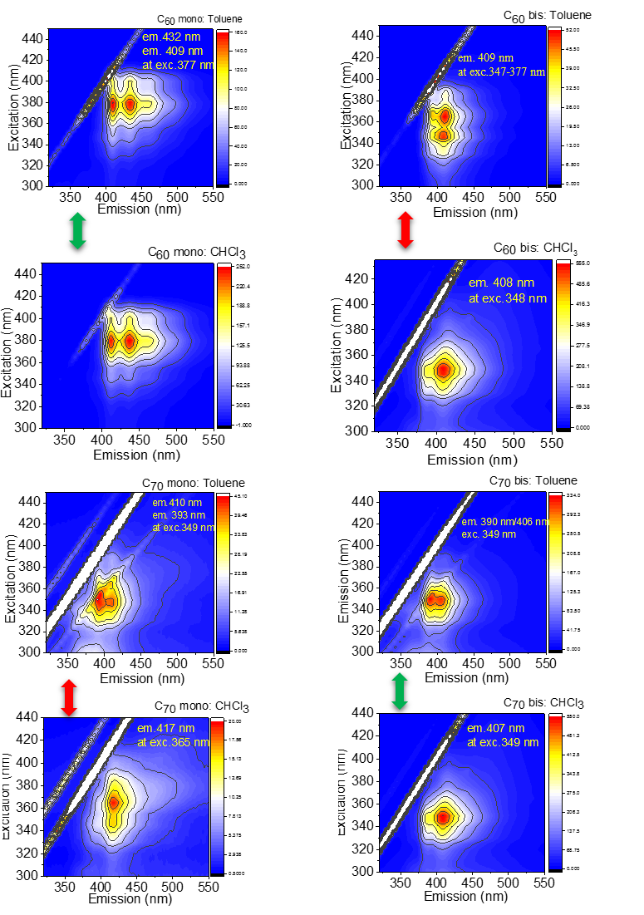
b)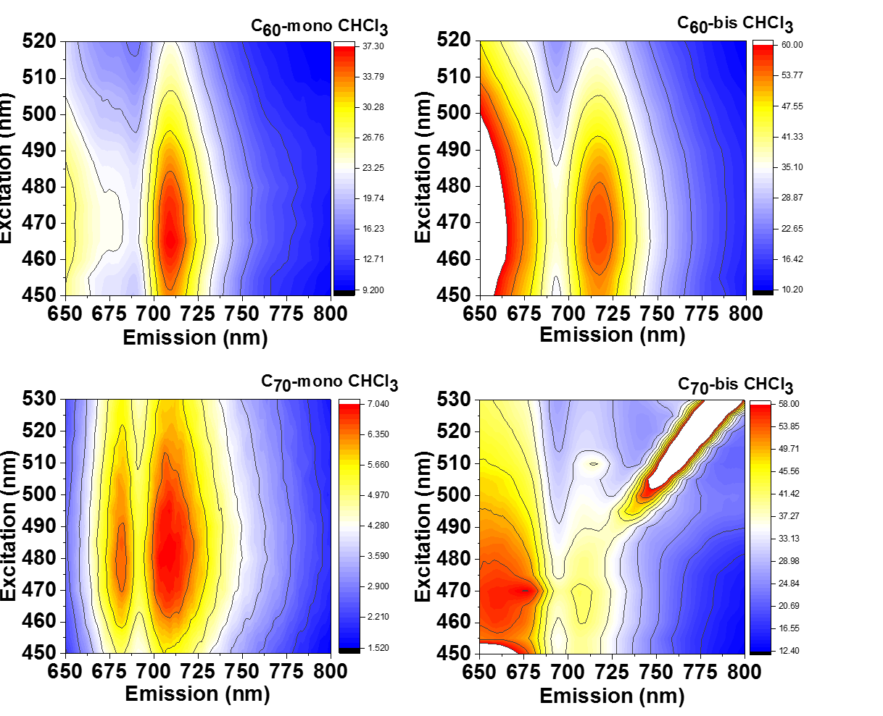
Figure S12. Comparison between the mono and bis adducts in toluene and chloroform solutions. The green arrows indicate that the spectra do not change, while the red arrows that small differences in terms of Stokes shifts or emission/excitation maxima are observed.

- Chapter 6: Residual fitting data
a)

b)
c)

Figure S13-I. Residual fitting data for the biexponential decays of the C₆₀-bis adduct. a) 462 nm b) 502 nm c) 550 nm
Figure S13-II. Residual fitting data for the biexponential decays of the C₆₀-mono adduct.
Figure S14. The instrument response function for the 1-pyrene carboxaldehyde at 422 nm with the artefact at 2.2 ns

