Fe₃O₄/Carbon Nanofibres with Necklace Architecture for Enhanced Electrochemical Energy Storage
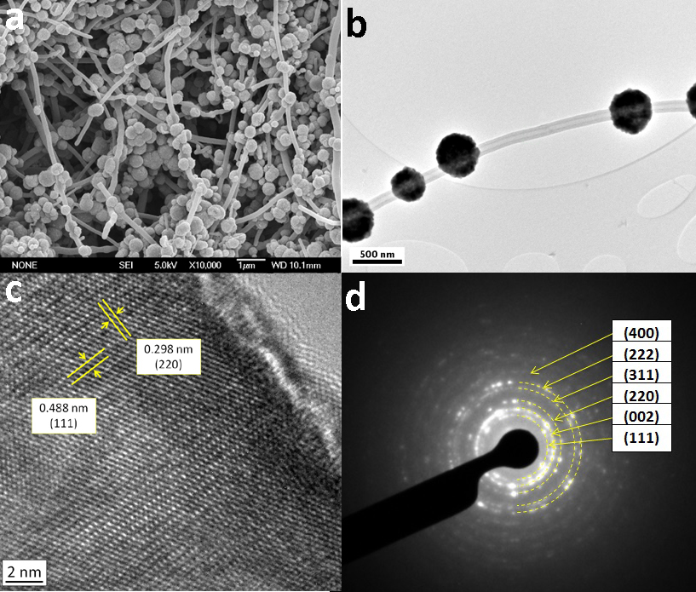
Figure 1 (a, b) SEM and TEM images of the as-prepared Fe₃O₄/CNF necklaces respectively, (c,d) HRTEM image and SAED pattern from the Fe₃O₄ bead respectively.

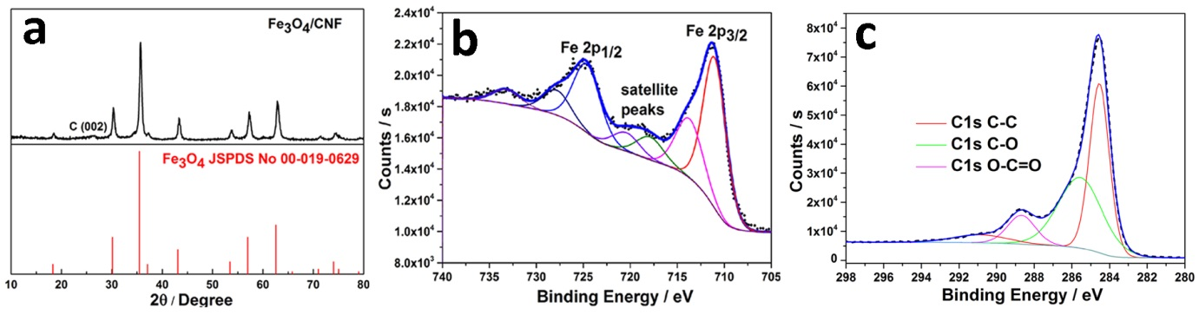
Figure 2 (a) XRD patterns, (b) the Fe 2p XPS spectrum, and (c) the C1s XPS spectrum of Fe₃O₄/CNF necklaces

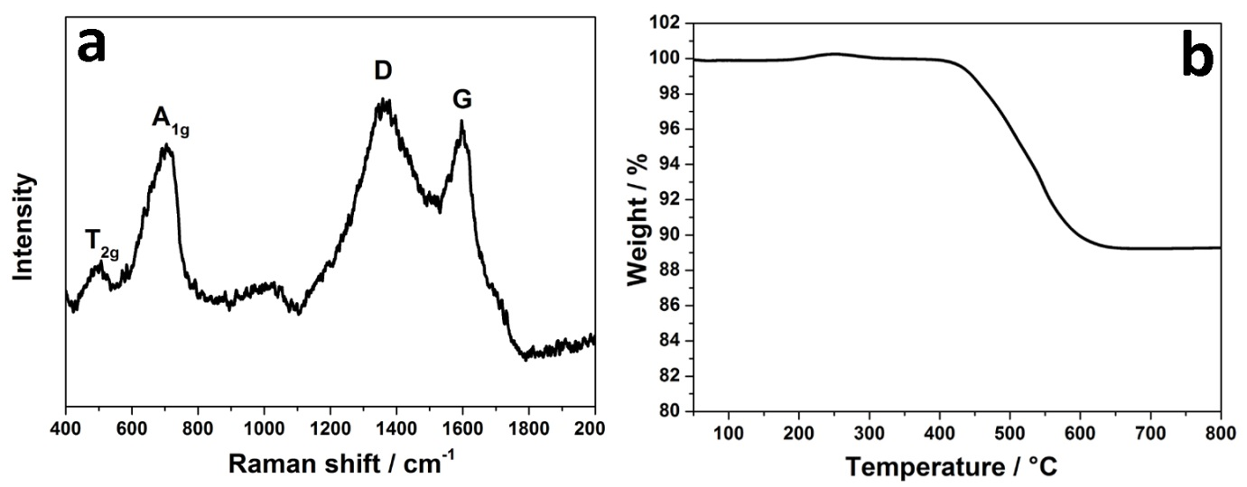
Figure 3 (a) Raman spectrum and (b) TGA profile of the Fe₃O₄/CNF necklaces.

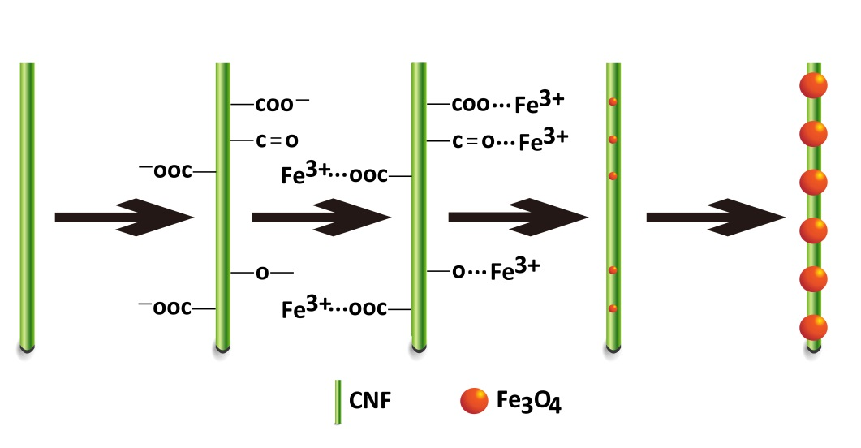
Figure 4 Schematic illustration of the proposed mechanism of formation of Fe₃O₄/CNF necklaces.

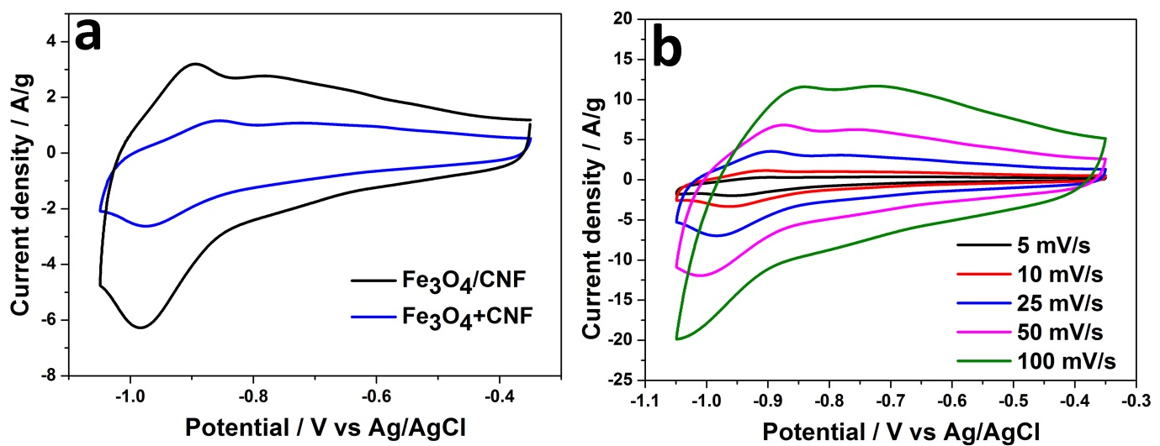
Figure 5 (a) CV curves of Fe₃O₄/CNF and Fe₃O₄ +CNF electrodes in KOH at 25 mV s⁻¹; and (b) CV curves of the Fe₃O₄/CNF necklace electrode at a range of scan rates from 5 mV s⁻¹ to 100 mV s⁻¹.

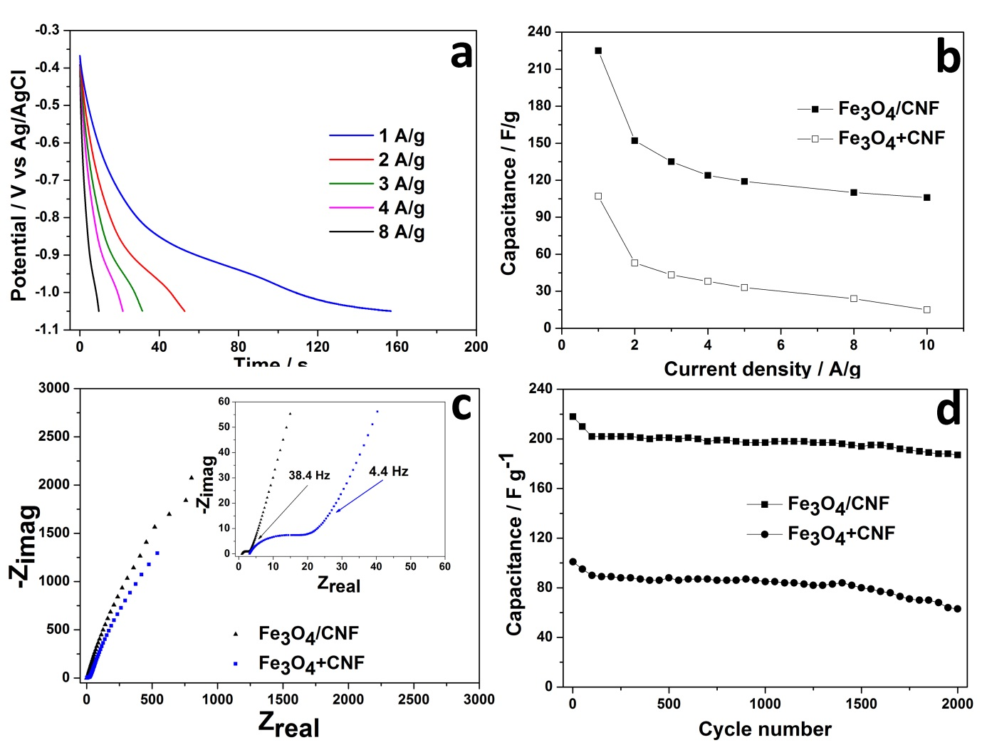
Figure 6 (a) Discharge curves of the Fe₃O₄/CNF necklace electrode at various discharge current densities; (b) specific capacitance as a function of current density for Fe₃O₄/CNF necklace and Fe₃O₄+CNF electrodes; (c) Nyquist plots with labelled knee frequencies; and (d) the specific capacitance as a function of cycle number for Fe₃O₄/CNF necklace and Fe₃O₄+CNF electrodes.

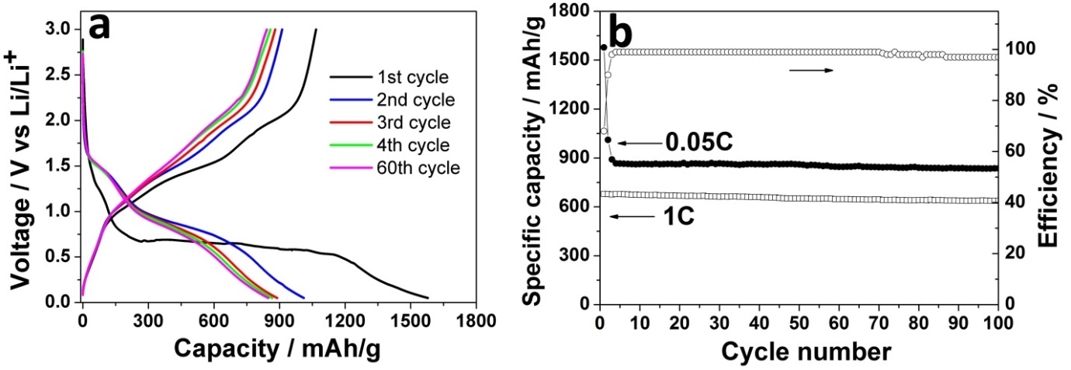
Figure 7 (a) Charge/discharge curves of the Fe₃O₄/CNF necklace electrode at 0.05C; and (b) specific capacity and efficiency as a function of cycle number.

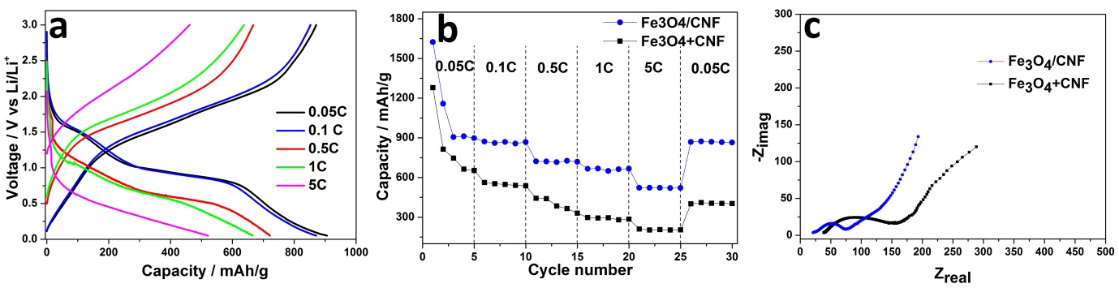
Figure 8 (a) Charge/discharge curves of the Fe₃O₄/CNF composite electrode at various rates, (b) Cycling performance at various rates and (c) Nyquist plots of the Fe₃O₄/CNF necklace and Fe₃O₄ +CNF electrodes.

