Supplementary Information
A new approach to very high lithium salt content quasi-solid state electrolytes for lithium metal batteries using plastic crystals
Danah Al-Masri,ª Ruhamah Yunis,ª Haijin Zhu,ª Liyu Jin,^{b} Peter Bruce,^{b} Anthony F. Hollenkamp^{c} and Jennifer M. Pringleª
ª Deakin University, Melbourne, Institute for Frontier Materials, Victoria 3125, Australia. Email:jenny.pringle@deakin.edu.au.
^{b} Department of Materials Chemistry, University of Oxford, Parks Road, Oxford OX1 3PH, UK.
^{c} Commonwealth Scientiﬁc and Industrial Research Organisation (CSIRO), Clayton, 3168, VIC, Australia.

Table S1. Transition temperatures (onset) and entropies for the [C₂epyr][FSI]/Li[FSI] salts, T_{s} = solid–solid transition, T_{m} = melting. Data for Li[FSI] obtained from ref [1]
 | T_{s} (°C ) ± 1 | ∆S (J K⁻¹ mol⁻¹) ± 10% | T_{m}(°C ) ± 1 | ∆S (J K⁻¹ mol⁻¹) ± 10%
[C₂epyr][FSI] | -35 | 36 | 129 | 9
90mol% LiFSI in [C₂epyr][FSI] | -50 | 1 | 94 | 28
Li[FSI] ^{[1]} | -51 | 2 | 140 | 41

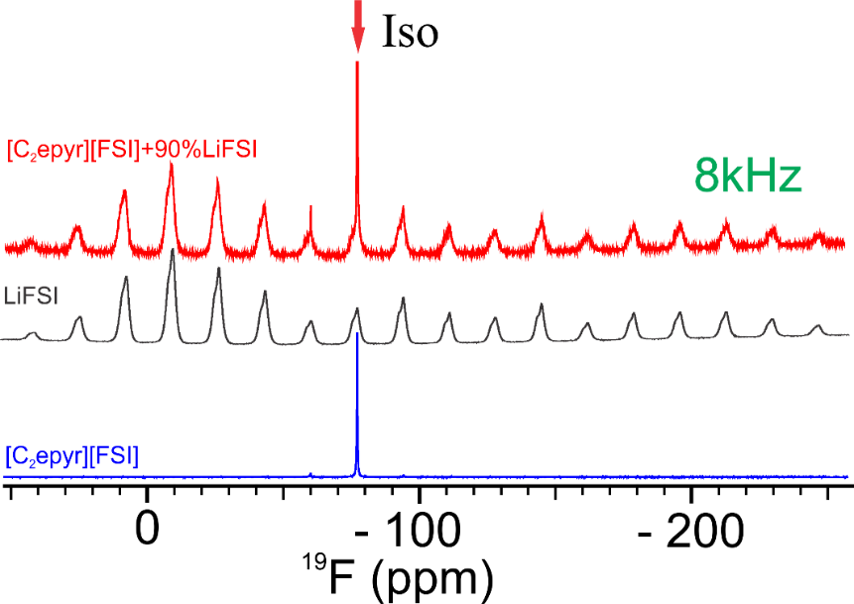
Figure S1. 8 kHz MAS ¹⁹F NMR spectra of neat [C₂epyr][FSI], neat Li [FSI] and 90 mol% Li[FSI] in [C₂epyr][FSI].

Figure S2. Cyclic voltammogram of the quasi-solid state 90 mol% Li[FSI] in [C₂epyr][FSI] electrolyte at 50°C. The arrows show the direction of peak progression from the 1st to the 4th scan, with platinum working electrode (2.0 mm² surface area), lithium strip as a quasi-reference electrode and a coiled lithium metal strip as counter electrode.

Figure S3. The Nyquist plots obtained after select plating cycles in a Li | Li symmetrical cell containing the quasi-solid 90 mol% Li[FSI] in [C₂epyr][FSI]. Cycling data shown in Figure 5 (a).

References.
[1] Y. Zhou, X. Wang, H. Zhu, M. Yoshizawa‐Fujita, Y. Miyachi, M. Armand, M. Forsyth, G. W. Greene, J. M. Pringle, P. C. J. C. Howlett, ChemSusChem 2017, 10, 3135.

