Identifying exacerbations using symptoms: reading between the lines
C G Johnson¹, R E K Russell², M Bafadhel²
Introduction: Exacerbations of COPD are associated with significant morbidity and mortality; however there is no clear consensus to the definition of an exacerbation and this remains subjective. Furthermore, it has been challenging to identify an individual biomarker, be it biological or physiological to identify an exacerbation, although identification of exacerbation phenotypes improves this. Most, if not all, patients report increase in symptoms during an exacerbation, measured using the visual analogue scale, performed on a 100mm line ranging from no symptoms to worst ever symptoms. However, it is unclear if there is a linear relationship with the increase in VAS symptoms and the onset of an exacerbation. In this study, we seek to mathematically model relationships with the VAS and symptoms of dyspnoea, sputum production, sputum purulence and cough in patients with COPD at stable state and during exacerbations.
Methods: Patients with COPD with completed assessments of VAS during both stable state and exacerbations were studied. An exacerbation was defined according to healthcare utilisation and increased symptoms. Classifier algorithms (Waikato Environment for Knowledge Analysis software ®) were run to predict the value of an exacerbation and multiple cross validation was used to assess the predictive accuracy. The Naïve Bayes (based on conditional probability), Multi-layer Perceptron (neural networks), J48 (decision tree) and Random Forest classifier were each run to model relationships.
Results: Data from 149 COPD subjects was collected, with 180 instances of an exacerbation recorded. The mean (SD) VAS (mm) for cough, dyspnoea, sputum production and purulence at baseline was 35 (27), 47 (27), 33 (27) and 28 (25) respectively. At exacerbation there was a significant increase (p<0.001) for all these parameters compared to stable state (mean difference, 95%CI for VAS cough, VAS dyspnoea, sputum production and purulence was 26mm (20-32); 25mm (19-30); 25mm (19-31) and 25mm (18-31) respectively.
The J48 classifier decision tree had the most predictive accuracy (80%) of identifying an exacerbation (figure 1), based on VAS and score.
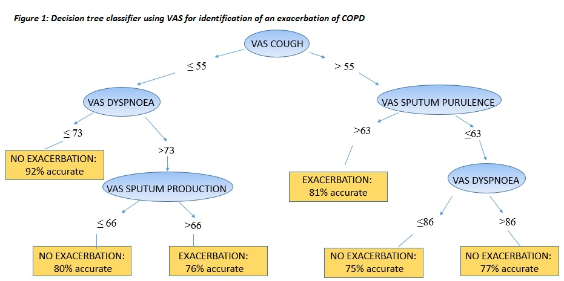

Conclusion: Unbiased mathematical modelling of the VAS may be useful in determining a true exacerbation event. The addition of characterisation based upon VAS may enhance the ability to identify exacerbations.

